Design and Applied Technology

Assessment Exercises

M5 - Visualisation and Computer-aided Design (CAD) Modelling

Curriculum Development Institute,
Education Bureau
(Trial version - March 2021)

Preface
This learning resource package was developed to provide DAT assessment exercises for teachers’ reference, so as to support the implementation of the DAT curriculum in schools and promotion of assessment for learning.
This learning resource package includes:
(i) Tips for Answering Questions
(ii) Two sets of Practice Questions
(iii) Marking Scheme and Answering Guide

Suggestions for use
- Teachers may share the Tips for Answering Questions with students to enable them to become familiar with the common question style, as well as gain confidence in interpreting the questions and planning the completion time.
- Teachers may guide students to complete related practice questions after teaching a topic to help students master what they have learned. Students may also practise answering questions within the suggested time duration. Teachers are advised to adapt the material according to the diverse learning needs of students if deemed necessary.
- Marking schemes with suggested answers are provided for each question. For ‘open-ended’ questions, example answers have been included. Students could refer to the marking schemes to understand about the answering requirements in each question.
- After completion of the practice question, students could refer to the Answering Guide to further understand the points to note for the question concerned.

*This is the trial version of the learning resource package. Teachers are welcome to provide comments and feedback by sending email to:
te_team4@edb.gov.hk

Table of Content

(i) Tips for Answering Questions 4
(ii) Question Paper 6
M5 - Visualisation and Computer-aided Design (CAD) Modelling (6 questions in total) 6
(iii) Marking Scheme and Answering Guide 15
Marking Scheme 15
Answering Guide 29

(i) Tips for Answering Questions

- General advice on answering questions
- Read the question carefully. Pay attention to all information provided in the question. It is a good practice to read the question twice to ensure you fully understand the answer requirements.
- Look at the number of marks allocated to each item in the question and determine whether marks would be awarded point by point based on the number of answers required, or according to the level criteria of the answer. The former only needs you to provide the corresponding number of correct answers; the latter needs you to determine the implicit requirements in the question carefully, and provide answers in response to each requirement with more details to obtain marks at a higher level.
- Underline the ‘command words’ and ‘key terms’ in the question before start.
- For longer questions, students should take time to think and plan the answers.
- For questions to be answered in the Question & Answer booklets, students could make reference to the space given when assessing how much to write.
- Example question:
Give two mechanical properties of mild steel that make it suitable for the construction industry. (2 marks)
Specific situation connected to the major information
Major information
Command word
Key term in this question
As deduced from the total mark, it is likely that one mark would be awarded for each property correctly named

- Where most of the marks lost when answering a question?
- Misunderstand (some) requirements of the question
- Ignoring (some) clues in the question
- Missing bits of a question
- Poor representation of information and/or annotations in diagrams
- Inaccurate diagrams
- Understanding command words
- The command words in questions instruct you to provide the answers required. Therefore, you need to understand the meaning of the command words used to prepare for the answers. The following are the commonly used command words in DAT:

Command word | What does it mean
- Analyse | Examine in detail to show meaning, identify elements and the relationship between them.
- Apply | To use previous learning and understanding in another familiar situation.
- Annotate | Add brief notes to a drawing, diagram or graph.
- Calculate | Work out from given facts, figures or information. Obtain a numerical answer showing the relevant stages in the working. You may use a calculator or equations.
- Compare | Identify/comment on similarities and/or differences.
- Describe | State the points of a topic / give characteristics and main features.
- Develop | Take forward to a more advanced stage or build upon given information.
- Draw / Produce | Represent by means of accurate diagrams or graphs using drawing equipment. A ruler should be used for straight lines. Diagrams and graphs should be drawn to scale.
- Distinguish | Make clear the differences between two or more concepts or items.
- Explain | Set out purposes or reasons / make the relationships between things clear / say why and/or how and support with relevant evidence.
- Give / State | Produce an answer from a given source or recall from memory. Express in clear terms.
- Illustrate / (Using annotated sketches to) Explain | Include examples or a diagram to show what you mean or demonstrate understanding of issues or concepts.
- Indicate | To show that something exists.
- Justify | Support a case with evidence/argument.
- List | Give a number of features or points without further elaboration.
- Name | Identify using a recognised technical term.
- Outline | A general description showing essential features.
- Sketch | Make a simple freehand and roughly proportional drawing showing the key features.
- Suggest | Apply knowledge and understanding to situations and propose a solution or other possible answers.

(ii) Question Paper

M5 - Visualisation and Computer-aided Design (CAD) Modelling (6 questions in total)

This question is about ‘Pictorial Drawing’ and has a total of 25 marks. The reference completion time is 25 minutes.
1. | (a) | Figure 1 shows two views of a toy car. The toy car is composed of seven separate parts.
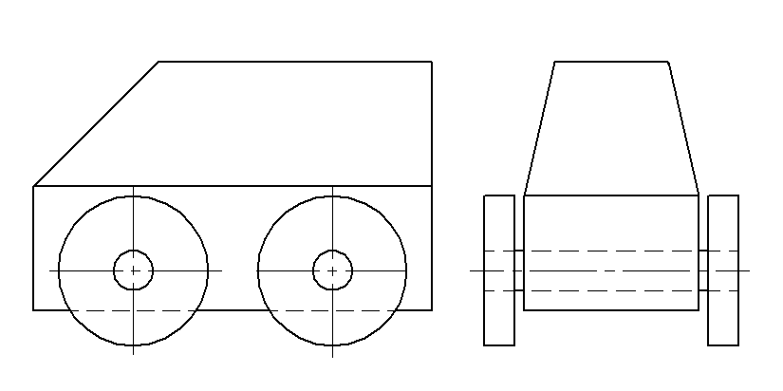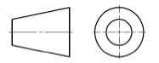
Body x 1 (Wood)
Wheel x 4 (Rubber)
Shaft x 2 (Stainless Steel)
 | Figure 1
- Sketch an exploded isometric view of the toy car. (8 marks)
- Render all separate parts of the car according to the materials indicated. (6 marks)
 | (b) |  | Figure 2 shows a pictorial view of the packaging box of the toy car.
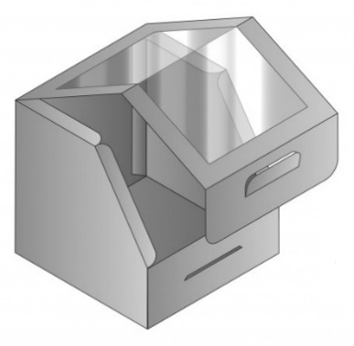
Body
Transparent window
A
 | Figure 2
 |  |  | Figure 3 shows an incomplete surface development of the packaging box . Draw all the remaining parts of the development, including faces of the box and the flaps. (Ignore the thickness of the materials. Use your judgement for any dimensions not given.) (7 marks)
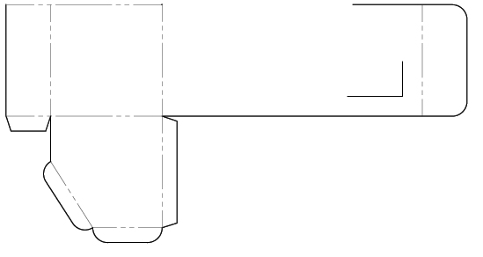
A
 |  |  | Figure 3
 | (c) |  | Using pictorial sketches, show a cardboard packaging accessory for restricting the toy car from moving inside the box. (2 marks)
 | (d) |  | Give TWO advantages of using computer aided design (CAD) software to model and test designs for packaging before manufacturing begins. (2 marks)

This question is about ‘Technical Visualisation’ and has a total of 25 marks. The reference completion time is 25 minutes.
2. |  | The figure below shows two views of a greenhouse in outline.
Door
Roof window
FRONT ELEVATION
END VIEW
- Use A as the lowest point, produce a two-point perspective drawing of the greenhouse. (18 marks)
- In the perspective drawing, show a door that opens outward and makes an angle of 90° with the side wall. (3 marks)
- In the perspective drawing, show a roof window that has been opened as shown in the end view. (4 marks)

Show all construction lines and indicate the auxiliary vanishing points (AVP) where necessary.

This question is about ‘Product visualisation’ and ‘Computer-aided Design’ and its ‘Applications’ and has a total of 25 marks. The reference completion time is 25 minutes.
3. | (a) | Figure 1 shows a plastic cutter.
 |  | 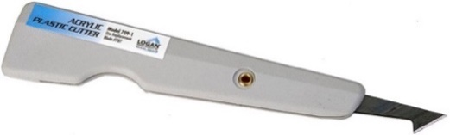
 |  | Figure 1
 |  | Using annotated sketches, show the following procedures of ‘cutting acyclic sheet with a plastic cutter’: (8 marks)
 |  | - Draw a guideline on the paper masking of the acrylic sheet with a pencil and a try square.
 |  | - Use plastic cutter with a try square/steel rule to score a narrow groove along the guideline on the acrylic sheet until it reaches about one-third of the thickness
 |  | - Using G-Clamp to the sheet firmly over a hard table edge with groove-side up.
 |  | - Bend the overhang side of the sheet with light, quick pressure to snap the piece into two.
 | (b) | Figure 2 shows some geometric solid primitives. Figure 3 shows an example of tree diagram of Constructive Solid Geometry (CSG) model.
 |  | 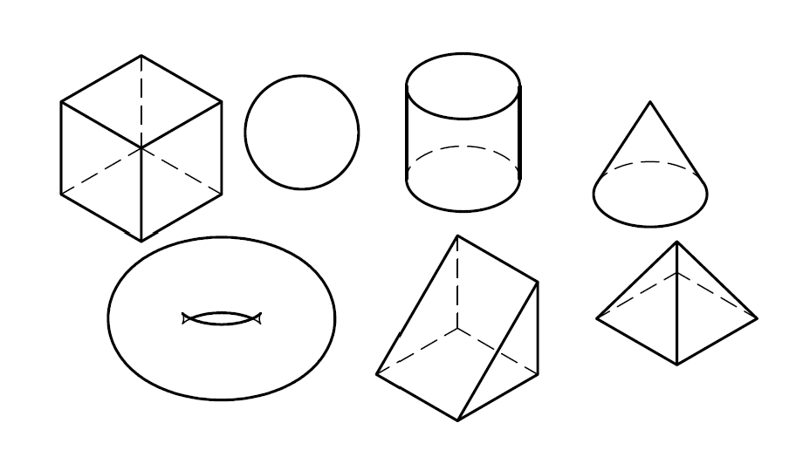 | 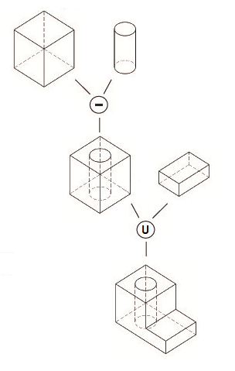
 |  | Figure 2 | Figure 3
 |  | Construct the tree diagram of CSG model that represents the object as shown in Figure 4. Ignore the dimensions of the object and assume that geometric solid primitives are oriented in the required orientation. (5 marks)
 |  | 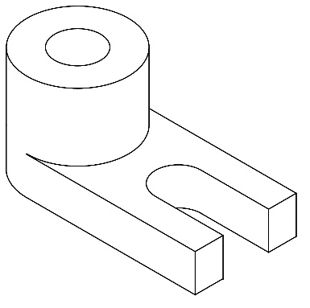
 |  | Figure 4
 | (c) | Figure 5 shows a guide block. Using annotated sketches, show the major steps of constructing a 3D model of the guide block using feature-based modelling approach. (10 marks)
 |  | 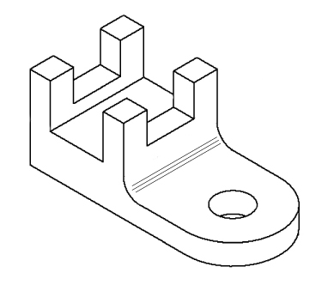
 |  | Figure 5
 | (d) | Give two reasons of the benefits of using CAD for developing new products. (2 marks)

This question is about ‘Technical Visualisation’ and has a total of 25 marks. The reference completion time is 25 minutes.
4. |  | The figure below shows an isometric drawing of a V-block and clamp assembly.
 |  | 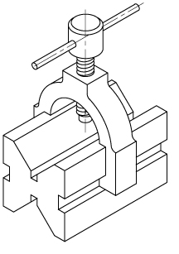
 | (a) | In the space provided below, produce the section X-X of the V-block and clamp assembly. All construction lines must be clearly shown. (13 marks)
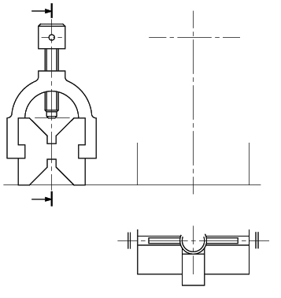
SECTION X-X
HALF PLAN
END VIEW
X
X
 | (b) | Sketch the V-block and clamp assembly in carbinet oblique projection with the receding axis inclined at 60° to the horizontal line. (12 marks)

This question is about ‘Technical Visualisation’ and has a total of 25 marks. The reference completion time is 25 minutes.
5. | (a) | Figure 1 shows an isometric drawing of a tea packaging carton box set. In the figure and with the light source provided,  - add tone shading to the box set to enhance its three-dimensional effect.  (5 marks)  - apply thick-and-thin lines technique to strengthen the outline of the box set. (2 marks)
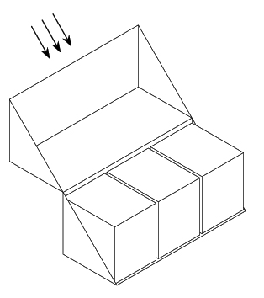
Parallel light source
A
 |  | Figure 1
 | (b) | Using A as the lowest point, draw a two-point perspective drawing of the tea packaging carton box set. Indicate the position of the Vanishing Points (VP) and the Eye Level Line (ELL) in your drawing. (11 marks)
 | (c) | Figure 2 shows a laser cutting pattern of a knock-down worktable model. Ignore the width of the laser cutting kerf.
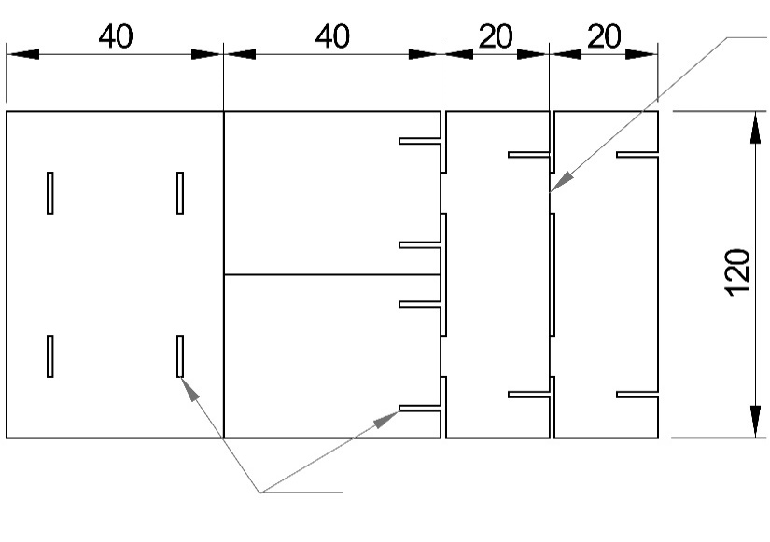
Material: Poplar plywood (2mm thick)
Tab
(15 × 2mm)
Slot (15 × 2mm)

Top
Side panel × 2
Apron × 2
 |  | Figure 2
 |  | - Using three dimensional pictorial sketches, show the steps of building the worktable model from the flat pattern into a 3D model (5 marks)
- State TWO functions of physical models in product visualisation.
(2 marks)

This question is about ‘CAD Modelling’ and has a total of 25 marks. The reference completion time is 25 minutes.
6. | (a) | Figure 1 shows an object. Using annotated sketches, show the major steps of constructing a 3D model of the object using feature-based modelling approach. (12 marks)
 |  | 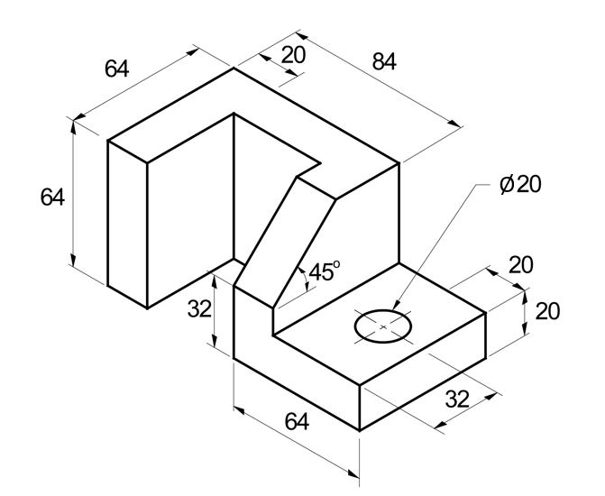
 |  | Figure 1
 | (b) | Figure 2 shows a mug, and Figure 3 shows the outline of the shape from which the mug body is constructed.  Using annotated sketches, show the steps of constructed the entire mug using feature-based modelling approach. Use your own judgement to determine the design and dimensions of the handle which are not given. (12 marks)
 |  | 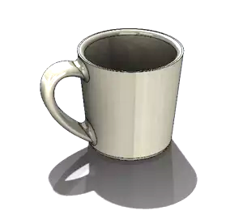 |  | 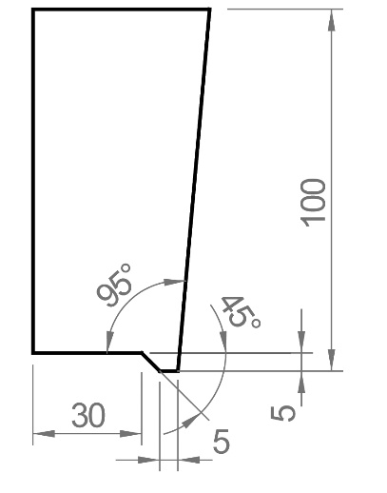
 |  | Figure 2 | Figure 3
 | (c) | State three advantages of virtual prototyping technology. (3 mark)

(iii) Marking Scheme and Answering Guide

Marking Scheme
 |  |  |  | Marks
1. | (a) | - Exploded isometric view of the toy car:
 |  | - Isometric view shown (1M)  - Body (1M)  - Shaft × 2 (1M)  - Wheel × 2 (1M)  - Position of each part in the exploded view (3M)  - Exploded line / alignment line shown (in dotted line) (1M) |  | (8)
 |  | Example: (For reference only)
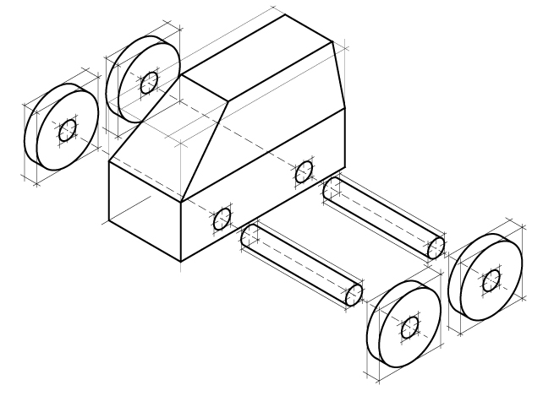
Explored line
 |  | - Rendering of all separate parts of the toy car:
 |  | Part Material Performance Marks  Body Wood - appropriate tonal change / gradation shown to enhance form / 3D effect - appropriate wood texture rendering shown 1 1  Wheels Rubber - appropriate tonal change / gradation shown to enhance form / 3D effect - appropriate rendering of matte surfaces shown 1 1  Shafts Stainless Steel - appropriate tonal change / gradation shown to enhance form / 3D effect - appropriate reflective rendering for metallic surface shown, including highlight 1 1 |  | (6)
 |  | Example: (For reference only)
 | (b) | Remaining parts/features of the development: (Correct shape, correct position, and correct line type of the following)
 |  | - Side (1M)  - Window (1M)  - Locking tab (1M)  - Slot (1M)  - Flaps (1M)  - Folding line A (1M)  - Folding line B (1M) |  | (7)
 |  | 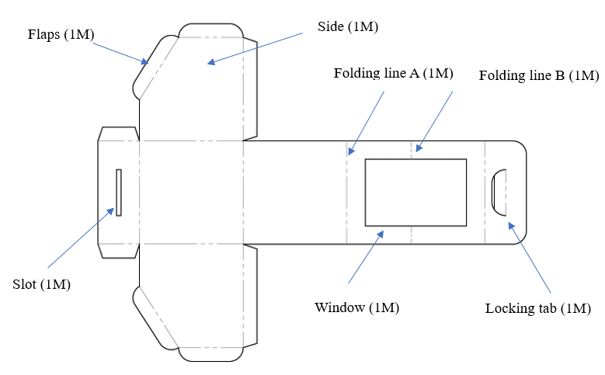
 | (c) | Cardboard packing accessory:
 |  | - Design that prevents the toy car moving inside the box: (e.g.) Built-in cardboard accessory with four grooves to match with the shape and size of the toy car wheels (1M)  - Working principle: (e.g.) Toy car wheels lock in the grooves would not be able to move (1M) |  | (2)
 |  | Example: (For reference only)
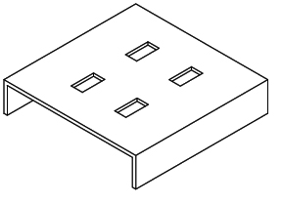
Groove
Cardboard accessory
 | (d) | Advantages of using CAD software: (Any two of the following)  (@1 × 2 = 2)
 |  | - CAD drawings can be easily edited, reused and transferred to other people.  - Easy to investigate an error, diagnose the problem, and solve it all using CAD software before any prototypes are made.  - Easy to transfer CAD files to production machery for direct production. |  | (2)
 |  | Total: |  | 25 marks

 |  |  |  | Marks
2. | (a) | - Perspective drawing of greenhouse:
 |  | - Using A as the lowest point (1M)  - Front wall: Method of subdividing into 4 parts (2M), proportion (2M)  - Side wall: Method of subdividing into 3 parts (2M), proportion (2M)  - Inside details (1M)  - Overall proportion: Crate size (2M)  - Auxiliary Vanishing Points (AVPs): Upper and Lower (2M)  - Proper orientation: Parallel lines converged to appropriate Vanishing Points (VPs) (2M)  - Line work: Outlines and construction lines (2M) |  | (18)
 |  | - Door:
 |  | - Opened outwards, at 90° with the side wall (1M)  - Proper orientation: Parallel lines converged to VP2 (1M)  - Appropriate proportion (1M) |  | (3)
 |  | - Roof window:
 |  | - The window frame and the opened roof window are drawn in the appropriate position on the roof top (2M)  - Proper orientation: Parallel lines converged to AVP2 (1M)  - Appropriate proportion (1M) |  | (4)
 |  | Example: (For reference only)
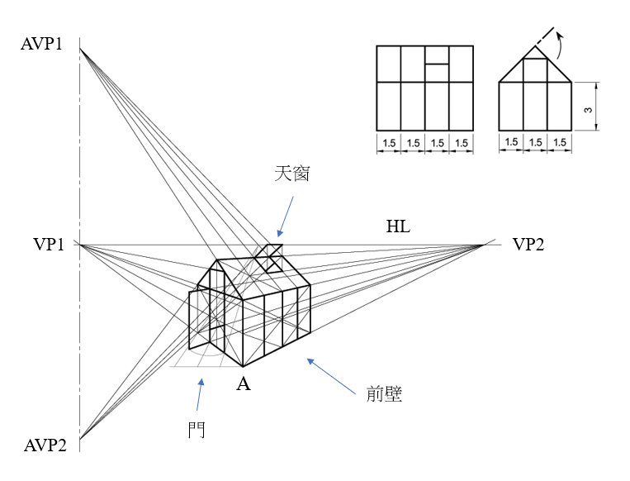
Roof window
Door
Front wall
 |  | Total: |  | 25 marks

 |  |  |  |  |  | Marks
3 | (a) | Procedures of cutting acyclic sheet with a plastic cutter: (@2 × 4 = 8) |  |  |  | (8)
 |  | Example: (For reference only)
 |  | - Draw a guideline on the paper masking of the acrylic sheet with a pencil and a try square. | 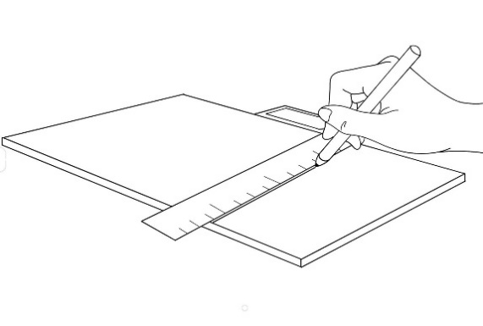  Try square
 |  | - Use plastic cutter with a ruler to score a narrow groove along the guideline on the acrylic sheet until it reaches at least one-third of the thickness | 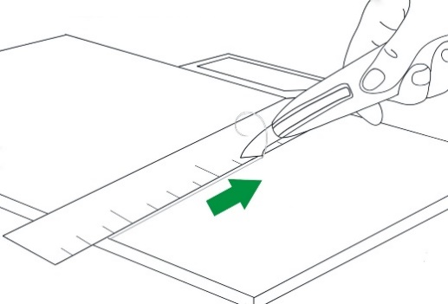  Plastic cutter刀
 |  | - Using a G-Clamp to clamp the sheet firmly over a hard table edge with groove-side up. | 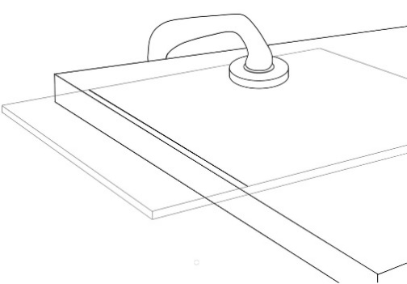  G Clamp  Groove-side up
 |  | - Bend the overhang side of the sheet with light, quick pressure to snap the piece into two. | 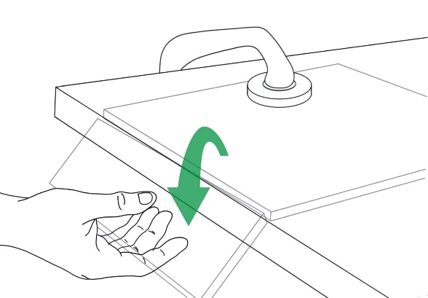
 | (b) | Construct binary tree of CSG model of the object:
 |  | - 4 steps: Primitive + Boolean Process (@1 × 4 = 4)  - Binary tree (1M) |  |  |  | (5)
 |  | Example: (For reference only)
 |  | 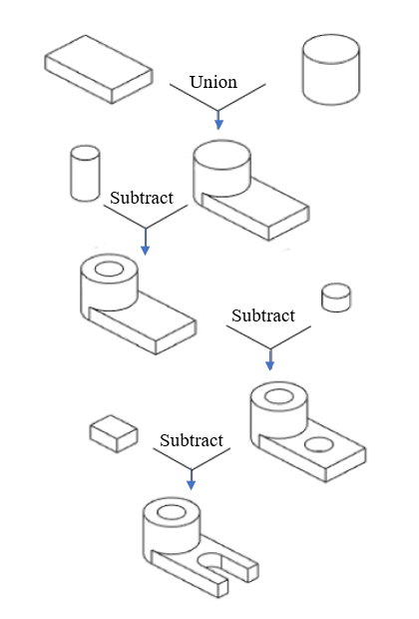
 |  | Major steps of constructing a 3D model of the guide block using feature-based modelling techniques:
 |  | Example: (For reference only)
 |  | 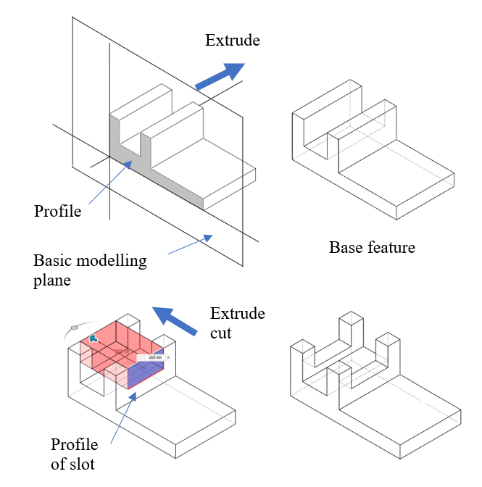 |  | - Sketch a profile on a basic modelling plane  - Extrude the profile to the required depth to obtain the desired base feature  - Select sketching plane, and create profile of the slot  - Extrude cut the profile to form the slot |  | (10)
 |  | 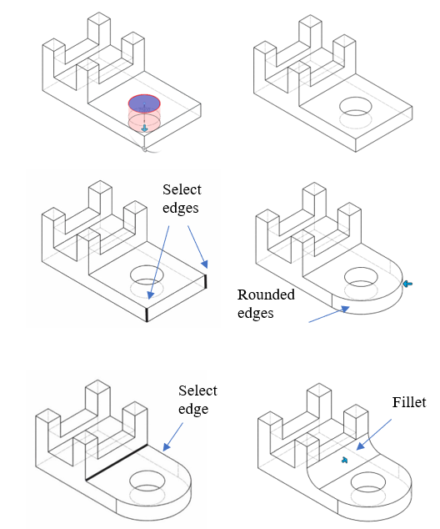 |  | - Select placement plane where the hole is to be added  - Extrude cut hole  - Select edges to be rounded  - Round the two edges  - Select the edge to be filleted  - Add fillet
 | (d) | Advantages of using CAD software: (@1 × 2 = 2)
 |  | - Using CAD allows design team members to collaborate. A member can work on the design and send it to other members, where they can view the design record to see exactly what has been done and share digital information with other people within the department and other stakeholders (e.g. clients).  - Using CAD allows design teams visualise their designs and test them against real-world variables, to detect errors, diagnose problems, and solve them all using the software before any physical prototypes are made. This not only saves time, but also money. |  |  |  | (2)
 |  | Total: |  |  |  | 25 marks

 |  |  |  | Marks
4. | (a) | Sectional view of V-block and clamp assembly:
 |  | - Sectional view:  - V-block (outline line, section line) (2M)  - Clamp (not sectioned; outline, section line) (2M)  - Screw (only the top portion is sectioned, the threaded portion is not sectioned; outline, section line) (3M)  - Handle (not sectioned, outline) (2M)  - Others:  - Correct size (1M)  - Line work: Neat and tidy (1M)  - Section line: On individual parts are drawn in different directions and spacings (2M) |  | (13)
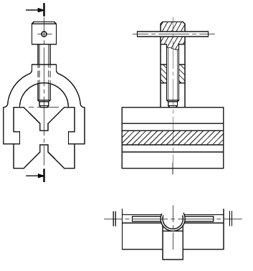
END ELEVATION
SECTION X-X
HALF PLAN
X
X
 | (b) | Cabinet oblique drawing of V-block and clamp assembly:
 |  | - Cabinet oblique drawing:  - V-block (outline) (2M)  - Clamp (outline, cross connection with V-block) (2M)  - Screw (outline of top and threaded parts, direction of ellipse) (3M)  - Handle (outline, direction of ellipse) (1M)  - Others:  - Appropriate proportion: Parts at the front are of same width and height as the original object; lines parallel to the oblique axis should be reduced to half (2M)  - Oblique axis: At 60° to the horizontal line (1M)  - Line quality: Neat and tidy (1M) |  | (12)
 |  | Example: (For reference only)
 |  | 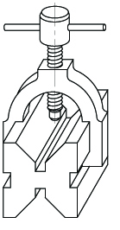
 |  | Total: |  | 25 marks

 |  |  |  | Marks
5. | (a) | - Use tone shading to enhance the three-dimensional effect:
 |  | - Appropriate (parallel) light source and direction (1M)  - Using appropriate levels (at least 3) of tone to enhance 3D effect (3M)  - Appropriate shadow cast on lid (1M) |  | (5)
 |  | - Thick-and-thin lines technique to enhance the outline:
 |  | - Appropriate drawing method: Thick line indicates the boundary of a hidden surface; and thin line represents two adjoining surfaces  - Thick lines: Represents all the outlines and boundary of hidden surfaces (1M)  - Thin lines: Represents two adjoining surfaces (1M) |  | (2)
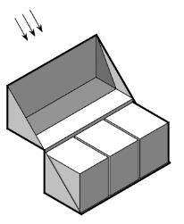Example: (For reference only)
Shadow cast on lid
Parallel light source
 | (b) | Two-point perspective drawing:
 |  | - Using A as the lowest point (1M)  - Overall proportion: Crate size (2M)  - Proper orientation: Parallel lines converged to appropriate VPs (2M)  - Appropriate method of multiplication/subdivision in construction (2M)  - Vanishing Points (VPs) and the Eye Level Line (ELL) / Horizon Line (HL) (2M)  - Line work: Outlines and construction lines (2M) |  | (11)
 |  | Example: (For reference only)
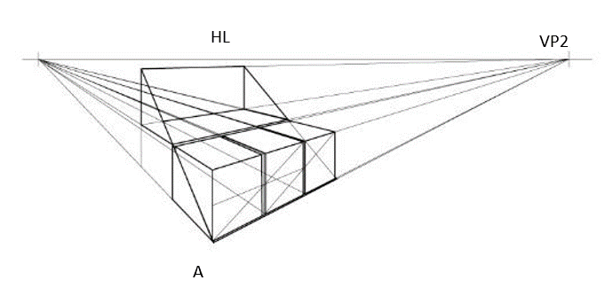
VP1
VP2
ELL
A
 | © | - Procedure of building the worktable model:
 |  | - Procedure: (In reasonable order) (e.g.)  (1) Align the slots on the two aprons in parallel and insert them into appropriate slots on the two side panels (2M)  (2) Align the slots on the table top and insert them into appropriate tabs on the two aprons (2M)  - Presentation: (e.g.) Using exploded view/sequential drawings (1M) |  | (5)
 |  | Example: (For reference only)
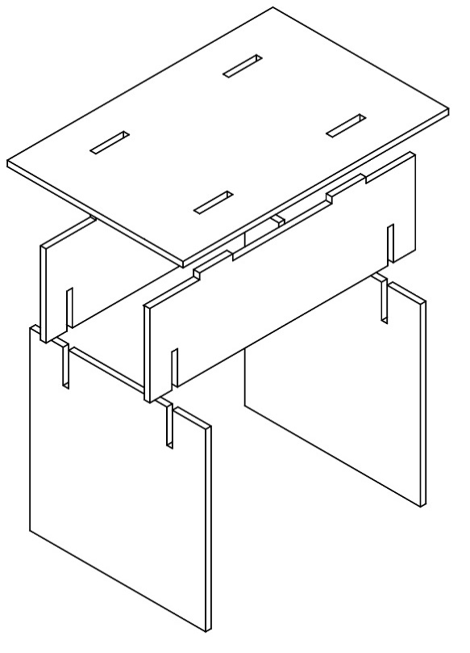
Step 1
Step 2
Side panel
Apron
In parallel
Top panel
 |  | - Functions of physical models in product visualisation. (Any TWO of the following) (@1 × 2 = 2)
 |  | - To show the form and functions of an object  - To show the internal structure of an object and the relationships between its parts  - To show external relationships of the structure of an object to the environment |  | (2)
 |  | Total: |  | 25 marks

 |  |  |  |  |  | Marks:
6. | (a) | Constructing a 3D model of the object using feature-based modelling approach: (@2 × 6 = 12) |  |  |  | (12)
 |  | 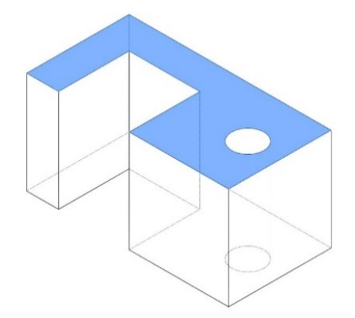  Extrude | - Sketch the required profile on the basic modelling plane  - Extrude the profile to the required depth to obtain the base feature
 |  | 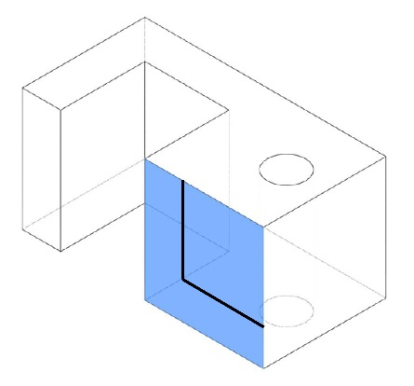  Extrude  cut | - Select the front modelling plane and create the square profile  - Extrude cut the profile to obtain the desired shape
 |  | 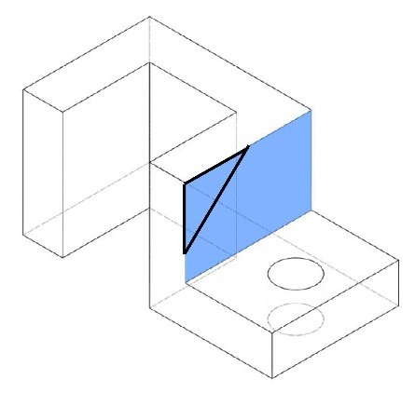  Extrude cut | - Select the modelling plane on the side, and sketch the triangular profile  - Extrude cut the profile to the required depth to obtain the desired shape
 |  | 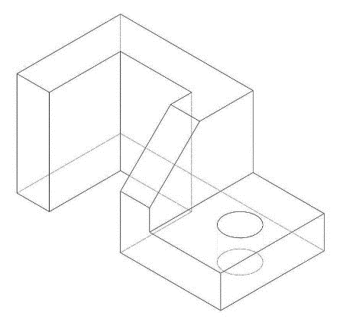 | - Completed shape
 | (b) | Steps for constructing the mug using 3D CAD modeling methods: (@2 × 5 = 10) |  |  |  | (10)
 |  | 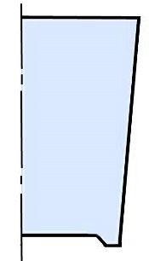 |  | - Sketch the profile of the mug body, and define the centre axis.
 |  | 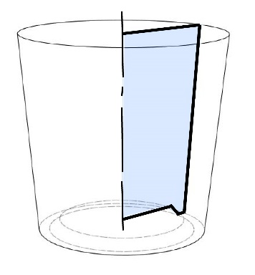 |  | - Use the ‘Revolve’ feature to construct the shape of the mug body
 |  | 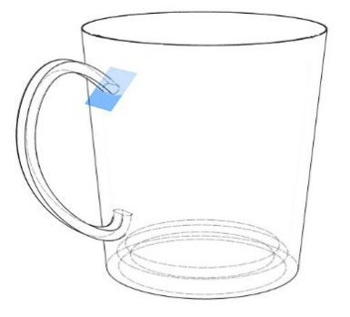  Cross sectional profile of the handle |  | - Sketch the profile (i.e. cross-section of the handle)  - Define the path and use the ‘Sweep’ feature to sweep the profile along the path to form the handle.
 |  | 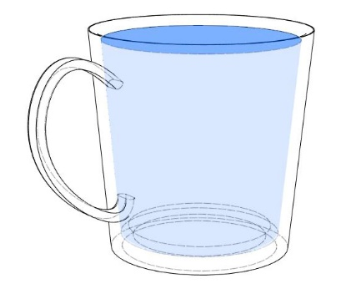 |  | - Select the top face of the mug and create the cavity of the mug by using the ‘shell’ feature.
 | (c) | Advantage of virtual prototyping technology: (@1 × 3 = 3)
 |  | - Easy to modify, so that the cost of revision is lower than that required to modify the physical prototype.  - Demonstrate product usage and special functions through animation and movement capabilities of the virtual prototype.  - Can use digital means to distribute product information to potential clients and broaden sales channels. |  |  |  | (3)
 |  | Total: |  |  |  | 25 marks

Answering Guide

Question No.
1(a) | Exploded Diagram
- Exploded diagram is a graphical communication technique that shows the relationship between parts by separating them, as if there has been a small ‘explosion’ along an axis.
- It shows how various components of a product are assembled together. Usually ‘exploded lines’ (dashed lines) are used as paths to show the connection position of the components.
- Not all components can be directly aligned with the connection point. In this case, you can pull out the component slightly and use the ‘exploded line’ to guide the component to the connection point.
3 | 3D CAD Modelling
 | - When answering this type of question, it is advised to use annotated sketches to illustrate description of the 3D CAD modelling process and not through written words alone. Do not use generic terms like ‘remove material’ or software-specific terminologies even if they correctly describe the 3D CAD modelling process.
4(a) | Partial View
 | - In this question, only one half of the plan view is drawn, with disruption takes place at the midline (symmetry line). This simplified method of representation, called partial view in technical drawing, saves time and makes the drawing clearer. The application of the partial view, however, is only for symmetrical components.
4(b) | Oblique Drawing
- Oblique drawing is the simplest 3D graphic type to produce. A 2D shape or the front elevation of an object is drawn first, then the sides are projected back at an angle (normally, 30°, 45° or 60°).
- There are two types of oblique drawings: Cavalier oblique and cabinet oblique drawings. For a cavalier oblique, the depth of the object is drawn to full scale. For the cabinet oblique, the depth is drawn to a length of half of the actual depth measurement to avoid distortion.
5(a) | Shading Technique
 | - When shading an object, it is very important to consider which direction the light is coming from, so that you can work out which surfaces have light falling directly on them and which surfaces will appear darker because they are in shadow.

