Design and Applied Technology

Assessment Exercises

S2 - Technological Principles

Curriculum Development Institute,
Education Bureau
(Trial version - March 2021)

Preface
This learning resource package was developed to provide DAT assessment exercises for teachers’ reference, so as to support the implementation of the DAT curriculum in schools and promotion of assessment for learning.
This learning resource package includes:
(i) Tips for Answering Questions
(ii) Two sets of Practice Questions
(iii) Marking Scheme and Answering Guide

Suggestions for use
- Teachers may share the Tips for Answering Questions with students to enable them to become familiar with the common question style, as well as gain confidence in interpreting the questions and planning the completion time.
- Teachers may guide students to complete related practice questions after teaching a topic to help students master what they have learned. Students may also practise answering questions within the suggested time duration. Teachers are advised to adapt the material according to the diverse learning needs of students if deemed necessary.
- Marking schemes with suggested answers are provided for each question. For ‘open-ended’ questions, example answers have been included. Students could refer to the marking schemes to understand about the answering requirements in each question.
- After completion of the practice question, students could refer to the Answering Guide to further understand the points to note for the question concerned.

*This is the trial version of the learning resource package. Teachers are welcome to provide comments and feedback by sending email to:
te_team4@edb.gov.hk

Table Of Content

(i) Tips for Answering Questions 4
(ii) Question Paper 6
S2 - Technological Principles (4 questions in total) 6
(iii) Marking Scheme and Answering Guide 11
Marking Scheme 11
Answering Guide 21

(i) Tips for Answering Questions

- General advice on answering questions
- Read the question carefully. Pay attention to all information provided in the question. It is a good practice to read the question twice to ensure you fully understand the answer requirements.
- Look at the number of marks allocated to each item in the question and determine whether marks would be awarded point by point based on the number of answers required, or according to the level criteria of the answer. The former only needs you to provide the corresponding number of correct answers; the latter needs you to determine the implicit requirements in the question carefully, and provide answers in response to each requirement with more details to obtain marks at a higher level.
- Underline the ‘command words’ and ‘key terms’ in the question before start.
- For longer questions, students should take time to think and plan the answers.
- For questions to be answered in the Question & Answer booklets, students could make reference to the space given when assessing how much to write.
- Example question:
Give two mechanical properties of mild steel that make it suitable for the construction industry. (2 marks)
Specific situation connected to the major information
Major information
Command word
Key term in this question
As deduced from the total mark, it is likely that one mark would be awarded for each property correctly named

- Where most of the marks lost when answering a question?
- Misunderstand (some) requirements of the question
- Ignoring (some) clues in the question
- Missing bits of a question
- Poor representation of information and/or annotations in diagrams
- Inaccurate diagrams
- Understanding command words
- The command words in questions instruct you to provide the answers required. Therefore, you need to understand the meaning of the command words used to prepare for the answers. The following are the commonly used command words in DAT:

Command word | What does it mean
- Analyse | Examine in detail to show meaning, identify elements and the relationship between them.
- Apply | To use previous learning and understanding in another familiar situation.
- Annotate | Add brief notes to a drawing, diagram or graph.
- Calculate | Work out from given facts, figures or information. Obtain a numerical answer showing the relevant stages in the working. You may use a calculator or equations.
- Compare | Identify/comment on similarities and/or differences.
- Describe | State the points of a topic / give characteristics and main features.
- Develop | Take forward to a more advanced stage or build upon given information.
- Draw / Produce | Represent by means of accurate diagrams or graphs using drawing equipment. A ruler should be used for straight lines. Diagrams and graphs should be drawn to scale.
- Distinguish | Make clear the differences between two or more concepts or items.
- Explain | Set out purposes or reasons / make the relationships between things clear / say why and/or how and support with relevant evidence.
- Give / State | Produce an answer from a given source or recall from memory. Express in clear terms.
- Illustrate / (Using annotated sketches to) Explain | Include examples or a diagram to show what you mean or demonstrate understanding of issues or concepts.
- Indicate | To show that something exists.
- Justify | Support a case with evidence/argument.
- List | Give a number of features or points without further elaboration.
- Name | Identify using a recognised technical term.
- Outline | A general description showing essential features.
- Sketch | Make a simple freehand and roughly proportional drawing showing the key features.
- Suggest | Apply knowledge and understanding to situations and propose a solution or other possible answers.

(ii) Question Paper

S2 - Technological Principles (4 questions in total)

This question is about ‘Mechanical Systems’ and has a total of 20 marks. The reference completion time is 20 minutes.
1. | The figure below shows a pull-along toy designed for young children. The toy has three carriages to be linked up together.
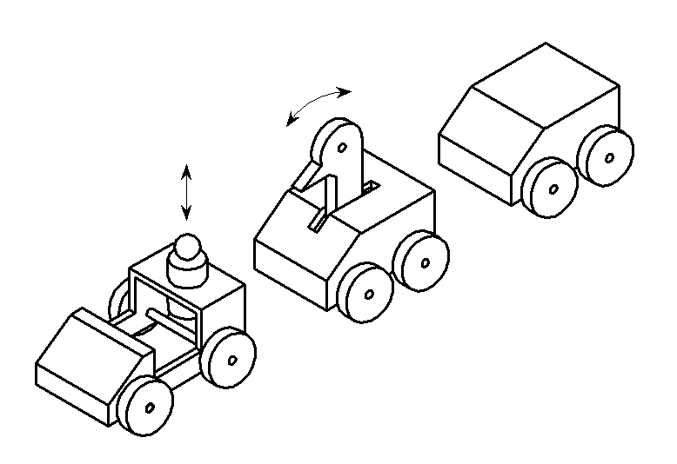
Human figure
Bird’s head
Carriage X
Carriage Y
Carriage Z
 | (a) | The human figure on Carriage X can move up and down as the toy is pulled along.
 |  | - Name the type of motion of the human figure. (1 mark)
 |  | - Using annotated sketches, show a mechanism that provides the required motion. Name the mechanism. (4 marks)
 | (b) | The bird’s head on Carriage Y can move to and fro as the toy is pulled along.
 |  | - Name the type of motion of the bird’s head. (1 mark)
 |  | - Using annotated sketches, show a mechanism that provides the required motion. Name the mechanism. (4 marks)
 | (c) | Using annotated sketches, show a mechanism that is inside the Carriage Z, which can produce sound as the toy is pulled along. (4 marks)
 | (d) | Using annotated sketches, show a method of linking the carriages to each other. The design should allow individual carriage to swing sideways freely while being pulled along. (4 marks)
 | (e) | State TWO safety considerations when designing pull-along toys for young children. (2 marks)

This question is about ‘Basic Electronics’ and has a total of 20 marks. The reference completion time is 20 minutes.
2. | The figure below shows the ‘paper circuit’ of a greeting card. The circuit is made out of copper tape, a LED and a button cell battery. The LED will switch on when the card is folded inwards.
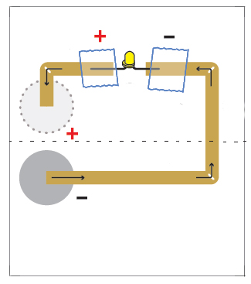
Folding line (fold inwards)
3V button cell battery
LED
Copper tape
 | (a) | Complete items and in the block diagram below which shows the operation of the paper circuit. (2 marks)  Process  Output  Input  Press the switch
 | (b) | Now it is required to modify the above circuit by adding a resistor.
 |  | - Show the modified circuit with a labelled circuit diagram using conventional electrical symbols. (3 marks)
 |  | - Explain the function of the resistor in this modified circuit. (2 marks)
 | (c) | A larger current flow through the circuit will make the LED grow brighter. Explain an undesirable consequence of excessive current passing through the LED.  (2 marks)
 | (d) | Now another LED is added to the circuit and connected in series with the original LED. Neither of the LEDs can light up.
 |  | - Give TWO reasons why the LEDs cannot light up. (2 marks)
 |  | - Suggest a method to overcome this problem. (1 mark)
 | (e) | Suggest another TWO daily applications of LED. (2 marks)
 | (f) | Give one physical property and one mechanical property of copper and explain why it is a suitable material for making the paper circuit. (4 marks)
 | (g) | Give TWO reasons why button cell batteries should not be disposed of in household rubbish bins. (2 marks)

This question is about ‘Mechanical Systems’ and has a total of 20 marks. The reference completion time is 20 minutes.
3. | The figure below shows an incomplete design of a shooting game. The target can oscillate sideways by moving Handle A.
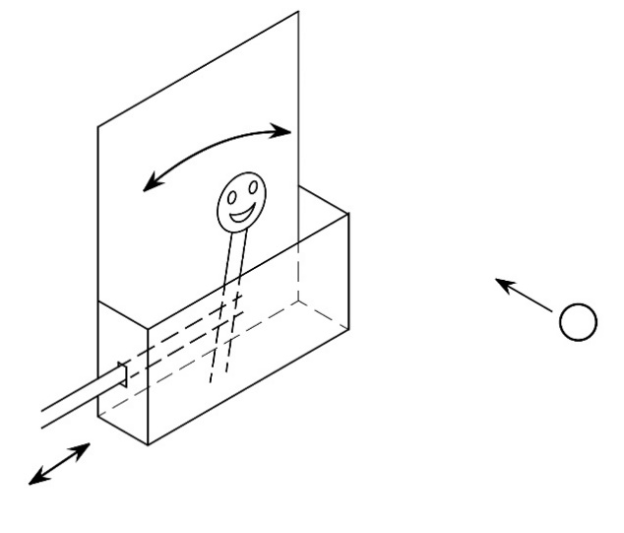
Moving target
Handle A
Ping-pong ball
 | (a) | Using annotated sketches, show:
 |  | - a set of linkage that makes use of Handle A to drive the moving target. (3 marks)
 |  | - a stopping device to restrict the movement of the moving target to within 60°. (3 marks)
 |  | - a shooting device that can adjust the launch angle and shoot ping-pong balls at a moving target. (8 marks)
 | (b) | Using annotated sketches, show:
 |  | - an improved design of Handle A to obtain a higher mechanical advantage. (3 marks)
 |  | - a mechanism that keeps the target moving with the use of a motor as the input. (3 marks)

This question is about ‘Mechanical Systems’ and has a total of 20 marks. The reference completion time is 20 minutes.
4. | (a) | Figure 1 shows a schematic diagram of a table lamp.
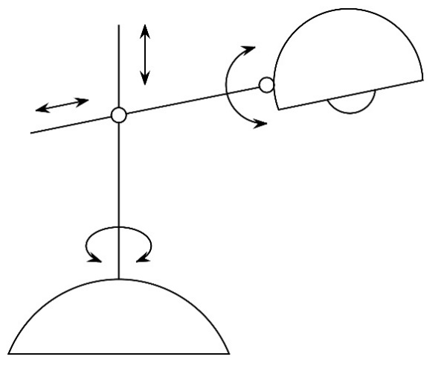
Arm
Part A
Lamp shade
Joint B

Post
 |  | Figure 1
Using annotated sketches, show
- the design of Part A that would allow the arm to be adjusted in the directions shown and locked in any desired positions. (4 marks)
 |  | - the design of Joint B that would allow the lamp shade to be adjust in the directions shown and locked in any desired positions. (3 marks)
 | (b) | Figure 2 shows a schematic diagram of a counterweight desk lamp. A balancing arm has on one side of the post a counterweight, and on the other side a lamp shade.
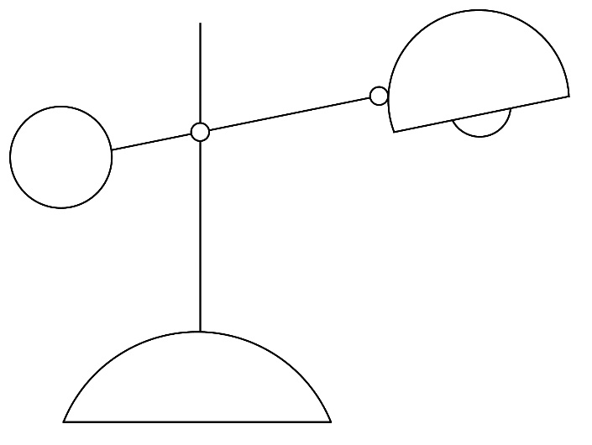
Post
Counterweight
Balancing arm
Lamp shade
Friction-free pivot
 |  | Figure 2
- Write down the class of lever that the arm of the lamp belongs to.
(1 mark)
- Using schematic diagram, explain the working principle of the counterweight desk lamp in keeping the arm in static equilibrium.
(4 marks)
 | (c) | Figure 3 shows an outline diagram of another balance-arm desk lamp.
 |  | 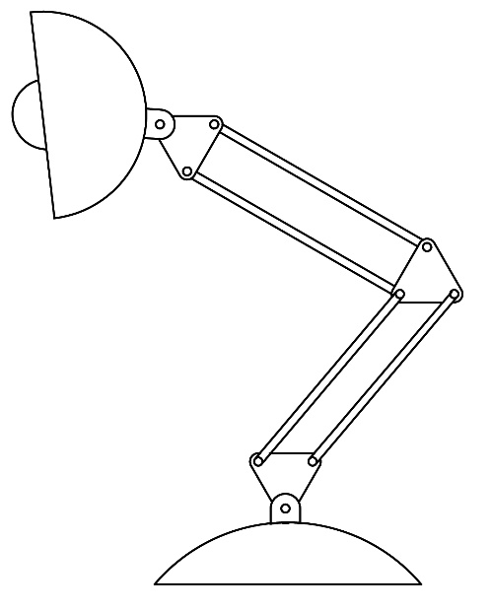
 |  | Figure 3
 |  | - Name the mechanism used on the balance-arm desk lamp. (1 mark)
 |  | - Using annotated outline drawing, add mechanical components that can keep the arms of the lamp in static equilibrium. Name the mechanical components added and explain its working principle. (7 marks)

(iii) Marking Scheme and Answering Guide

Marking Scheme
 |  |  |  | Marks
1. | (a) | (i) Name the type of motion involved:
 |  | - Reciprocation (reciprocating motion) |  | (1)
 |  | (ii) A mechanical system to provide the required movement
 |  | - Name of mechanism: (e.g.) Eccentric cam and follower (2M)  - Method of producing the required movement (1M)  - Technical feasibility: Location and method of installing to the carriage (1M) |  | (4)
 |  | Example: (For reference only)
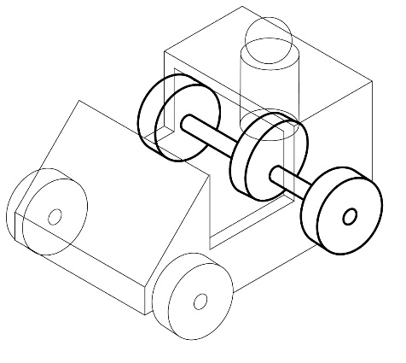
Eccentric Cam
Follower
 | (b) | - Name of the type of motion involved:
 |  | - Oscillation (Oscillating motion) |  | (1)
 |  | - A mechanism to provide the required movement:
 |  | - Name of mechanism: (e.g.) Crank shaft and linkage mechanism (2M)  - Method of producing the required movement (1M)  - Technical feasibility: Location and method of installing to the carriage (1M) |  | (4)
 |  | Example: (For reference only)
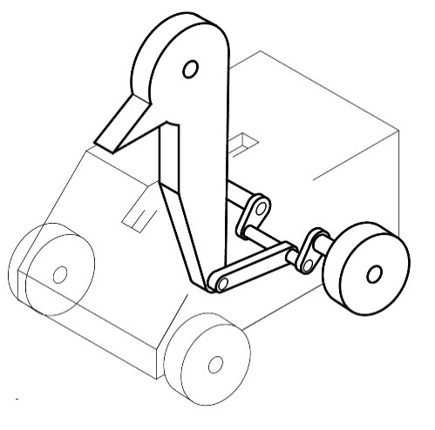
Linkage
Crank
 | (c) | A mechanism that produce sound:
 |  | - Appropriate mechanism: (e.g.) Snail cam and follower (2M)  - Method of producing sound: (e.g.) Vibrating the spring leaf (1M)  - Technical feasibility: Location and method of installing to the carriage (1M) |  | (4)
 |  | Example: (For reference only)
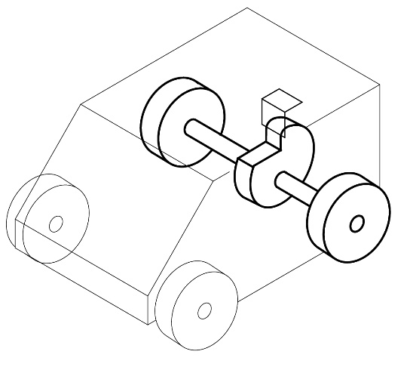
Snail Cam
Spring leaf
 | (d) | A method of linking the carriages to each other:
 |  | - Connection method: (e.g.) Using hinged joint (2M)  - Method of allowing the carriage to swing sideways: (e.g.) Turn about the axis (1M)  - Technical feasibility: Location and method of installing to the carriage (1M) |  | (4)
 |  | Example: (For reference only)
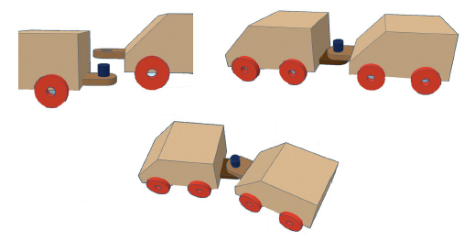
Hinged joint
 | (e) | Safety consideration when designing pull-along toys for young children: (Any TWO of the following) (@1 × 2 = 2)
 |  | - No long cords on the push-pull toy. Any string or cord attached to a toy should be at least 1.5 mm thick to avoid cuts to children.  - No small components or parts which can easily come off, to avoid children to swallow the small parts.  - No sharp points and edges or finger traps  - No toxic materials |  | (2)
 | Total: |  |  | 20 marks

 |  |  |  |  |  | Marks
2. |  | (a) | Block diagram to show the operation of the paper circuit.
 |  |  |  | Input  Process  Output  Press switch  LED lights up  Electric current passed through circuit |  | (2)
 |  | (b) | (i) Modified circuit diagram:
 |  |  | 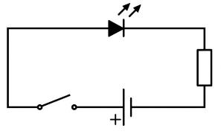  Switch  Cell battery  Resistor  LED |  |  | (3)
 |  |  | The circuit diagram should show: Symbols of LED, resistor, cell battery and switch and correct connections.
 |  |  | (ii) Function of the resistor in the modified circuit
 |  |  | - The resistor is used to limit the current flowing (1M), otherwise the LED will burn out. (1M) |  |  | (2)
 |  | (c) | Undesirable consequence of excessive current passing through the LED:
 |  |  | - Allowing more current to flow through the LED will make it glow brighter but will also cause it to dissipate more heat. (1M)  - As temperature increases, the forward voltage of the LED decreases, causing the LED to draw more current. The LED will continue to get hotter and draw more current until the LED burns itself out. (1M) |  |  | (2)
 |  | (d) | (i) Reasons why the LEDs cannot light up: (@1 × 2 = 2)
 |  |  | - Add more LEDs in series to the circuit, the total voltage required to power all the LEDs in the loops also goes up.  - LEDs are diodes that require a certain voltage before they let any through. The LEDs cannot light up as the shared voltage is not enough to trigger the diodes. |  |  | (2)
 |  |  | - A method to fix the problem:
 |  |  | - The power source must provide an appropriate voltage, use two 3V cell batteries in series instead. |  |  | (1)
 |  | (e) | Two daily applications of LED: (Any TWO of the following)  (@1 × 2 = 2)
 |  |  | - Visual signals: where light goes more or less directly from the source to the human eye, to convey a message or meaning  - Illumination: where light is reflected from objects to give visual response of these objects  - Data communication and other signalling |  |  | (2)
 |  | (f) | Physical properties of copper: |  |  | (2)
 |  |  | - Good electrical conductivity: with higher conductivity than most metal
 |  |  | Mechanical property of copper: |  |  | (2)
 |  |  | - Good ductility/malleability: being able to pull/rolled into thin foil/tape, and easily bend to form the shape of the circuit
 |  | (g) | Improper disposal of button cell battery: (@1 × 2 = 2)
 |  |  | - Button batteries contain extremely toxic materials such as mercury, lead, cadmium, and nickel, which may contaminate the environment when batteries are improperly disposed of.  - Button batteries are quite small, young children and toddlers might accidentally swallow them. |  |  | (2)
 |  |  | Total: |  |  | 20 marks

 |  |  |  | Marks
3. | (a) | - A mechanical device linked up to Handle A for driving the moving target:
 |  | - Appropriate method: (e.g.) Using slotted link mechanism (2M)  - Technical feasibility: Can fit the original design (1M) |  | (3)
 |  | - Stopping device:
 |  | - Appropriate method: (e.g.) Using stop pins (2M)  - Technical feasibility: Can fit the original design (1M) |  | (3)
 |  | Example: (For reference only)
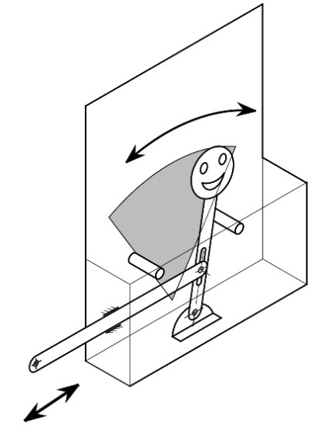
Stop pin
Slotted link mechanism
Handle A
Moving Range
 |  | - Shooting device：
 |  | - Method and device of adjusting launch angle: Can move in all directions or up and down/left and right (2M)  - Power source: (e.g.) Making use the elasticity of a spring as power (2M)  - Method of holding the ball before launching: (e.g.) Put the ball in the guide tube one by one or store a number of balls in a hopper (2M)  - Accurately launching ping-pong balls: (e.g.) With a tube of appropriate length (1M)  - Stability: (e.g.) A solid structure and base, which can maintain the stability of the device before and after shooting (1M) |  | (8)
 |  | Example: (For reference only)
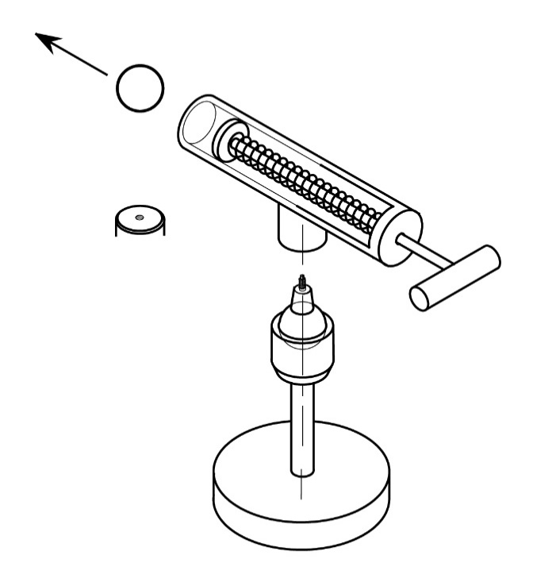
Make use of elastic spring as power source
Ball joint-allows smooth movement in multiple directions within a limited range
Reverse of bottom of guide tube (with threaded hole)

Guide tube
Wide base
 | (b) | - An improved design of Handle A:
 |  | - Appropriate method: (e.g.) Using reverse motion linkage, Increase length of output arm, so that output arm D > input arm d (2M)  - Technical feasibility: Can fit the original design (1M) |  | (3)
 |  | Example: (For reference only)
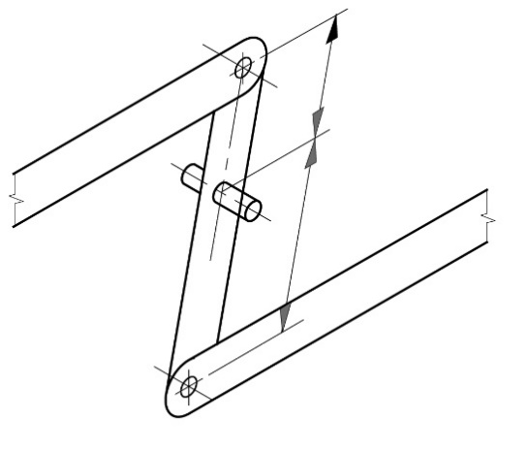
D
Pivot
Input motion and force

Output motion and force
d
Increase length of output arm,
D > d
Handle A

 |  | - A mechanical device that keeps the target moving:
 |  | - Appropriate mechanical device: (e.g.) Using crank and connecting rod mechanism/slider crank mechanism (2M)  - Technical feasibility: Can fit the original design (1M) |  | (3)
 |  | Example: (For reference only)
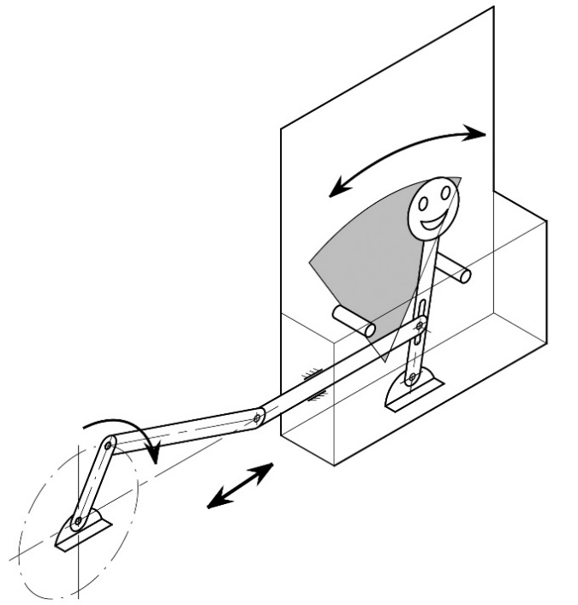
Crank and connecting rod mechanism
 |  | Total: |  | 20 marks

 |  |  |  | Marks
4. | (a) | (i) Design of Part A:
 |  | - Appropriate method: Allow the arm to be adjusted along its length and the post (2M) and locked in any desired positions(1M), (e.g.) using a clamp with bolt and nut  - Technical feasibility: Can fit the original design (1M) |  | (4)
 |  | Example: (For reference only)
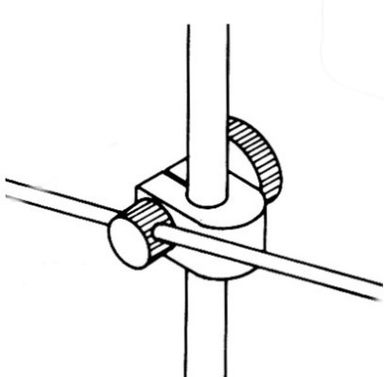
Nut
Clamp
Bolt
 |  | - Design of Joint B:
 |  | - Appropriate method: (e.g.) Hinged joint (2M)  - Technical feasibility: Can fit the original design (1M) |  | (3)
 |  | Example: (For reference only)
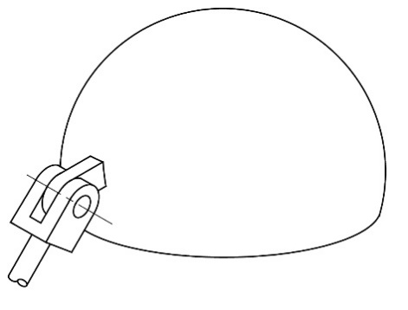
Hinged joint
Shade
 | (b) | - Class of lever:
 |  | - First class of lever |  | (1)
 |  | - Working principle:
 |  | - The principle of moments (1M) which states that when in equilibrium (balance) the total sum of the anti-clockwise moment is equal to the total sum of the clockwise moment. (2M)  - Annotated schematic diagram shown (1M) |  | (4)
 | (c) | - Mechanism involved:
 |  | - Name: Four-bar linkage/parallel motion mechanism |  | (1)
- Mechanical components added: Two springs in appropriate locations (2M)
- Working principle:
 |  | - The lamp has two four bar linkages (parallel motion linkages) (2M) and two elastic (extension) springs (1M).  - The upper spring controls the upper arms which are parallel to each other. (1M)  - The lower spring controls the lower arms which are parallel to each other. (1M) |  | (7)
 |  | Example: (For reference only)
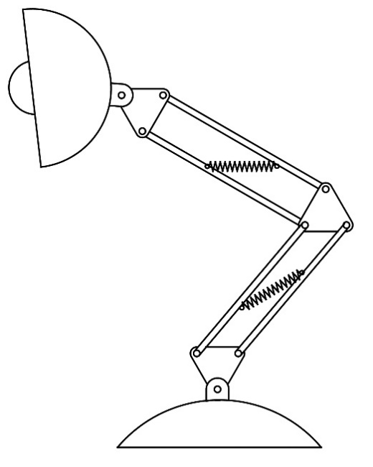
Four-bar linkage
Spring
Four-bar linkage
 |  | Total: |  | 20 marks

Answering Guide

Question No.
1 | Label, Annotation and Descriptive Text
- Purely using graphics to display information about objects or designs would sometimes be inadequate. When necessary, ‘labels”, annotations’ and ‘descriptive texts’ can be added to drawings and diagrams.
- ‘Labels’ are descriptive, for example, color, texture or materials.
- ‘Annotations’ should clearly, concisely and concretely explain the development of design ideas, such as design decisions being made.
- ‘Descriptive texts’ are usually used to explain or add information to the product's function, structure, method of use, or the manufacturing technology under consideration. They can also explain the idea behind the drawing and the design concepts involved.
- Effective use of texts and annotations is an excellent way for demonstrating knowledge and understanding of design factors, materials and manufacturing processes.
2(a) | Block Diagram
 | - Block diagrams are usually written with headings such as ‘input’, ‘process’ and ‘output’ in rectangular boxes. These headings will be used to plan input, process, and output details when designing how the circuit will function.
4(a)(b) | Schematic Diagram
 | - A schematic diagram is a picture that represents the components of a process, device, or object using abstract, often standardised symbols and lines. For example, schematic diagram can be used to depict different parts of the lamp as a set of shapes or symbols that show how they are positioned relative to one another.
4(c) | Outline Drawing
 | - An outline drawing consists of only contours or external lines of an object without adding any shading.

