Assessment 2
Fill in the major colour pigment in the vegetable |  | Fill in expected colour after different treatments
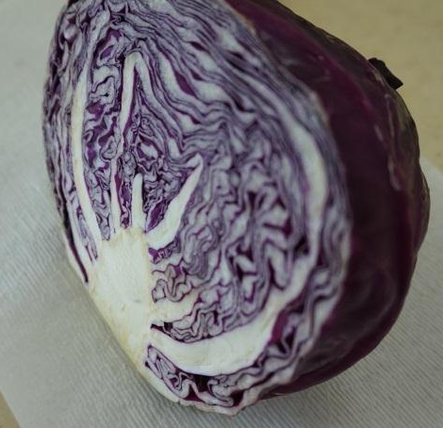  Major colour pigment :  ____________________ | Cook with vinegar  Cook with baking soda
Boil for long time
Boil in alkaline medium

Major colour pigment :

____________________
Major colour pigment :  ____________________ | Boil for long time

