Culture and Fashion Design

- The Evolution of Historical Western Costume in the 20th Century
- economic factors influence the fabrics, styling and quality that are popular or available at a given time
- technology plays its part through the development of new materials and new methods of construction
- global events, music video, movie and celebrities have had a great influence on fashion in the twentieth century

1900s
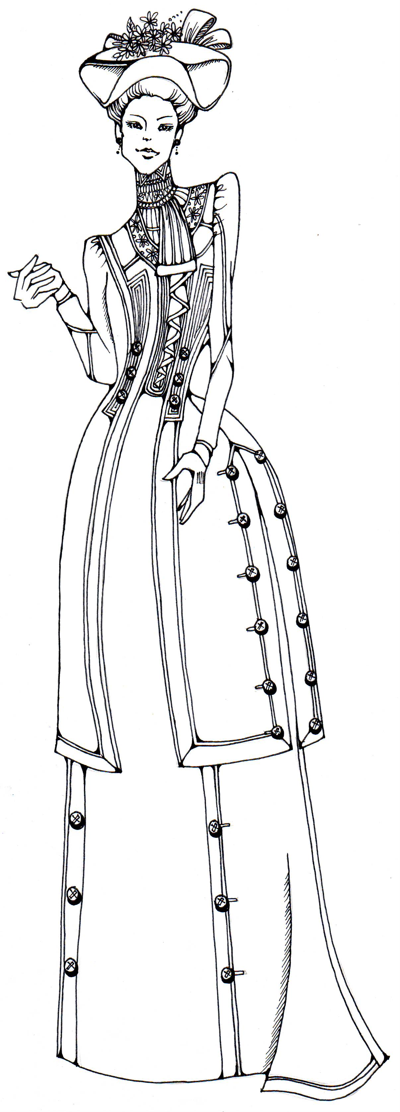
Women’s wear
- the bust-line was protruded and the waistline was controlled by the corset which was known as the “S” band shape
- women’s dresses were long and full skirted, often had bustles which emphasised the hips
Men’s wear
- the three-piece suit for gentlemen was introduced

1910s
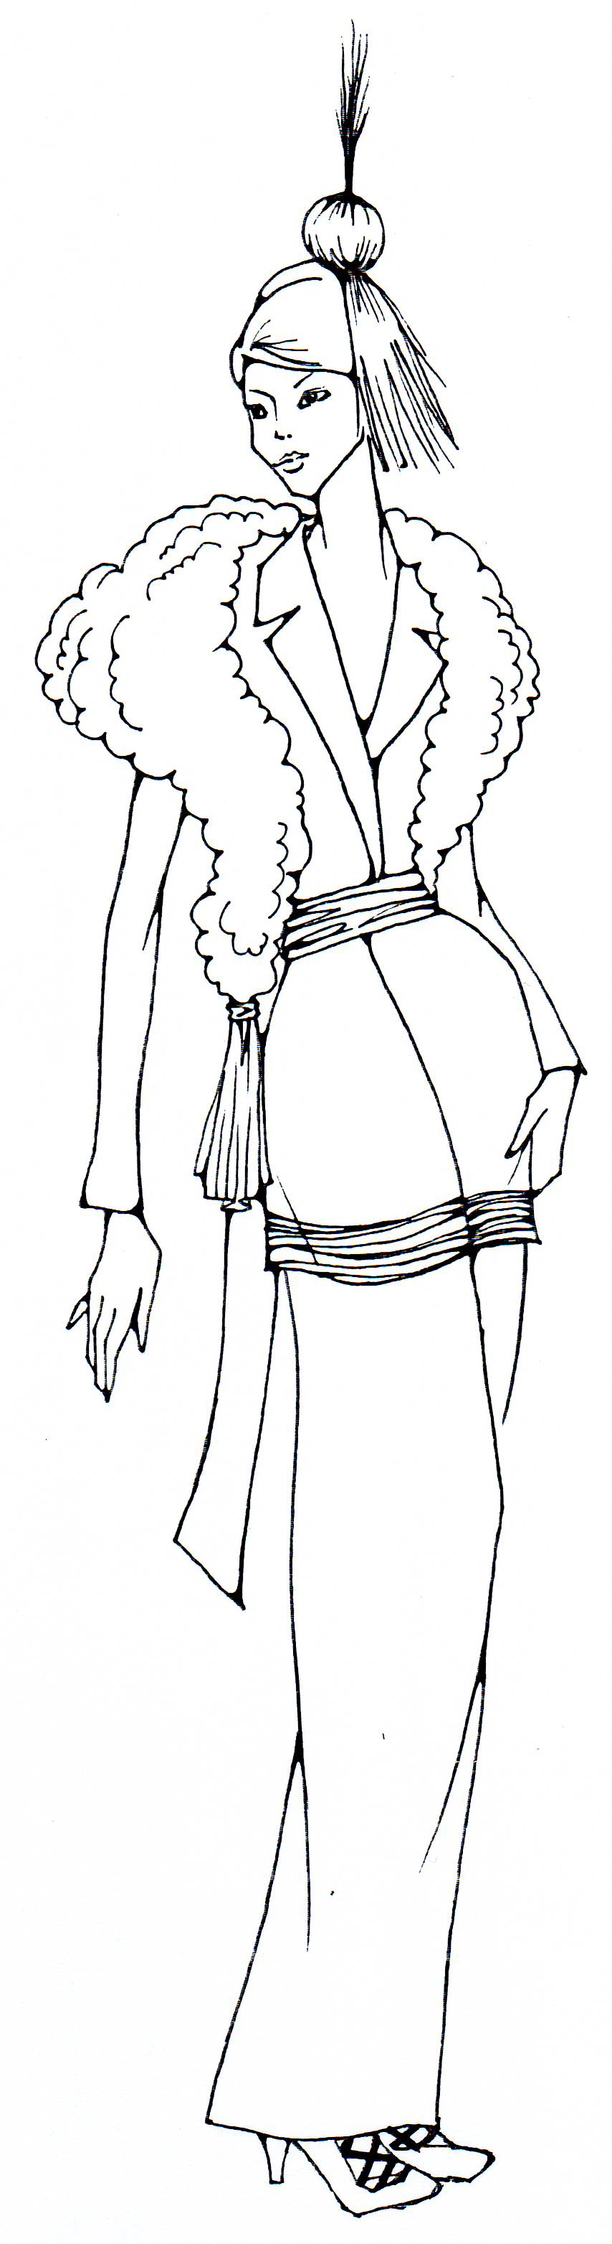
- the hourglass figure continued to be in style but without the “S” shape
- skirts became narrower at the hemline, high and close-fitting turtle neck or V neck
- during the First World War - trousers were popular, hemlines of skirts were moved upwards to ankles or lower leg
- after war - dresses and suits made from jersey fabrics, looser garments such as middy blouses with sailor collars and sweaters

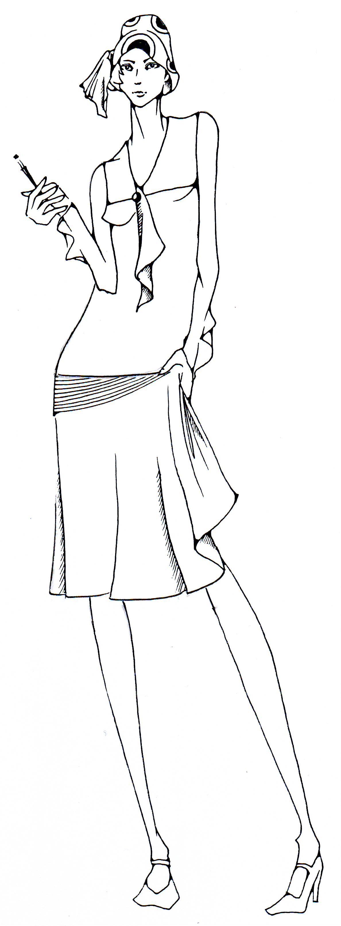
1920s
- clothes became shorter and less fitted comfort and practicality
- less class-conscious and youthful styles with rectangle silhouette
- the flapper – dresses with dropped waist were usually worn with long pearl necklaces and bobbed hair

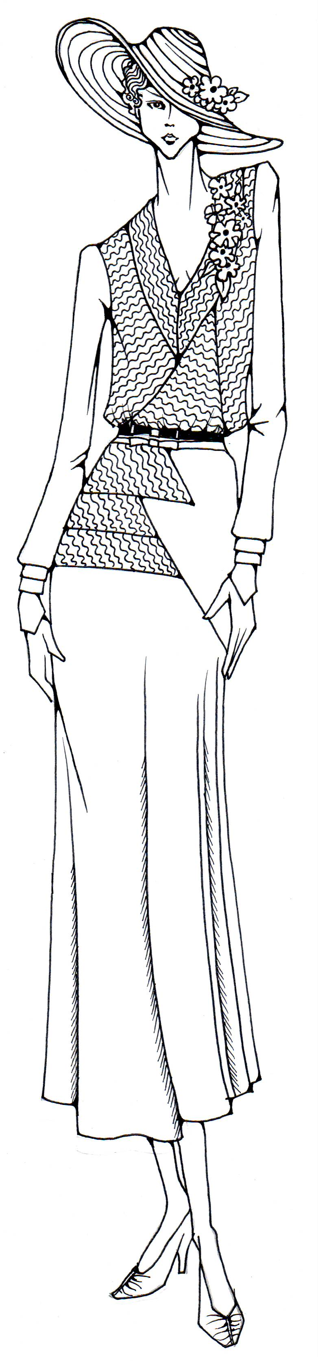

1930s
- classic suits and dresses, separate skirts and blouses were a highlight
- natural shape silhouette with a narrow waist and high shoulders
- hemline went down again
- skirts were often made with godets or pleats which started below the knee

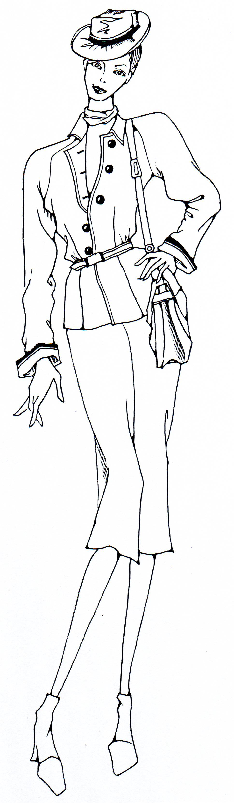
1940s
- influenced by the Second World War – slimmer styles, shorter skirts (hemline back to knee level) and nipped-in waistlines in order to use less fabric
- emphasised the natural curve of bodies, shoulder pads are used

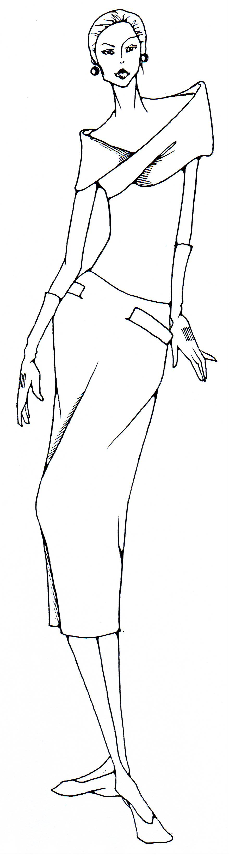
1950s
Women’s wear
- corsets were disposed but still emphasised waistline and hips
- sleeves were usually short or three-quarter in length, a large variety of collar types, skirts were with mid-calf length and often flared below the knee
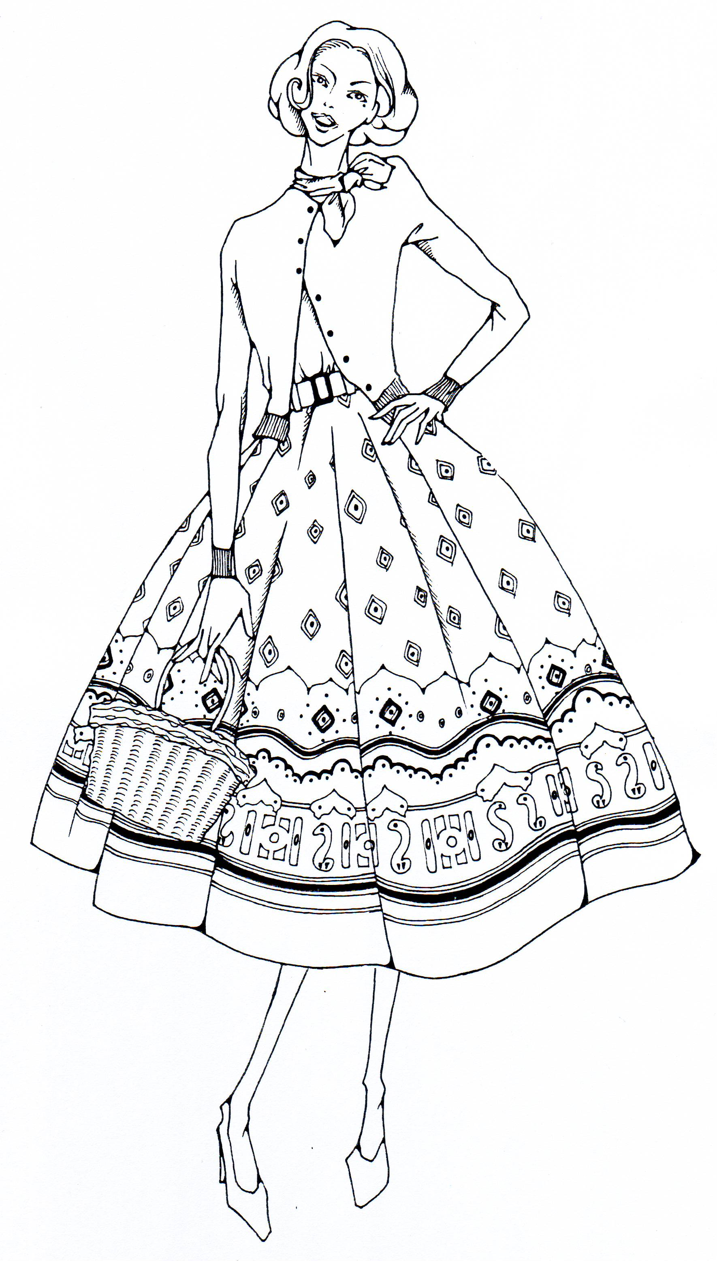
- clam diggers, pedal pushers cape-like coats with wide sleeves, sloping shoulders were worn
Men’s wear
- young men - button-down oxford shirts, oxford shoes, and narrow regimental ties
- business uniform - narrow lapels gray sack-cut suit with striped tie, wing-tip oxford shoes and a gray fedora hat
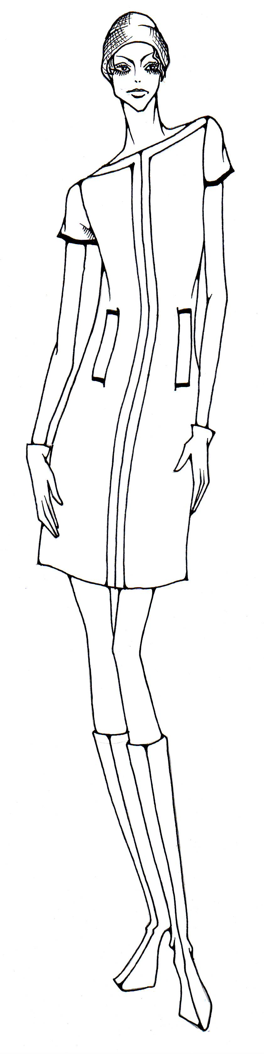

1960s
- miniskirts with tight boots and hippie style
- pop art pattern and geometric dress shape, PVC dress
- emergence of the “unisex” look

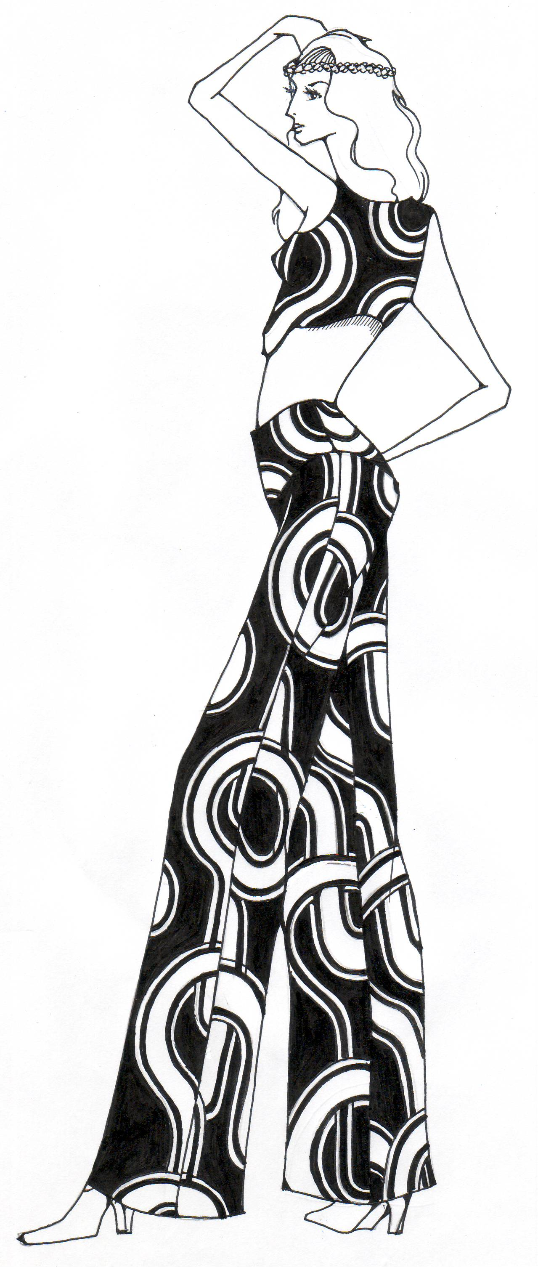

1970s
- denim jeans with bell-bottom and hipster, tight fitting shirts
- street style fashion with spiky and slashed details on clothes, unisex styles
- hot pants, pantsuits and jeans were popular for women’s wear
- men wore suits with large butterfly bowties, wide collars, wide neckties, leisure suit with bright floral shirt worn beneath the jacket and without a necktie
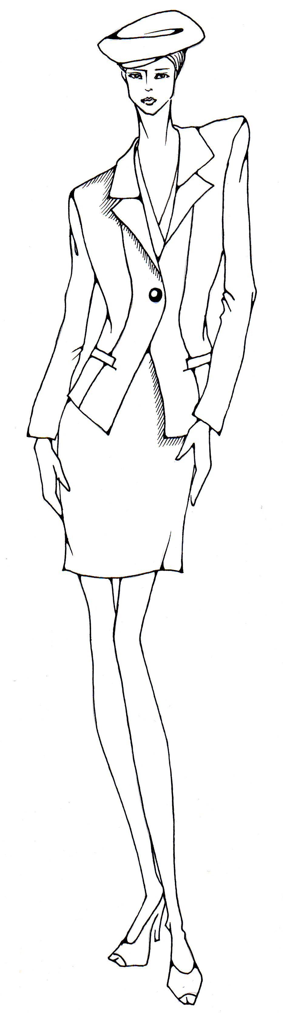

1980s
- skirt lengths ranged from long to short
- broad shouldered and tailored power suits / pantsuits with excess use of should pads
- popular clothes for women in the job market include broad and big jacket with tight skirt and a feminine blouse

1990s
- fashions became more natural in shape, styles ranged from bagged pants to tight leggings, from oversized shirts to skinny tops
- fashion tended to be more causal, both men and women were dressing less formally

- National Costumes of East Asia & India
- clothing can be a valuable clue to various cultures
- the style of clothing that people wear – the designs, the fabrics and the colours – can tell you a lot about the way how the people of a given culture think, their heritage, values and believes

- costumes of China – Qi Pao
- a traditional Chinese style which developed early in the Qing Dynasty
- the origin of qi pao is that Manchu women normally wore a one-piece dress which came to be called “qi pao” of “banner dress”
- costumes of Japan - Kimono
- all kimonos are the same shape that can be worn by anyone, man or woman, regardless of height or weight
- emphasizes the beauty of straight lines
- when the kimono is worn, the lines are free falling
- costumes of India
- men’s wear - The men’s costume is based on the turban, which is called pagri in India, is a piece of white or colourful cotton or silk printed with or without a border
- women’s wear - Sari is the most important and common garment for Hindu women in India

- Factors Contributing to Fashion Trends in Local and Global Context
- fashion trend
trend may refer to:
- the process of getting others to follow or copy
- current style such as the latest ‘fashion style”
- trend can be called “vogue”
- something popular
- movement of fashion
- the change of fashion
- geographical and environmental factors such as weather, climatic, location
- social influences such as lifestyle
- technological development such as high-tech materials
- economic influences such as simplicity versus glamour
- political Influences such as embargo
- cultural developments such as believes and religion

4. Major Fashion Trend

Elegant

Feminine

Ethnic

Sportive

Mannish

Avant-
garde

Modern

Classic
Major Trend

