How much do you know about “COVID-19”? (Teachers ' Version)

Level: Primary One to Three students

Target: 1. Students are able to understand the clinical features, prevention and mode of
transmission of “COVID-19”.
2. Students are able to select appropriate information from their reading.

Points to note for teachers:
1. Encourage parents to read with their children.
2. Explain difficult terms and concepts, e.g. clinical features…
3. Encourage students to browse the website of CHP, Department of Health (https://www.coronavirus.gov.hk/eng/index.html) if interested.

Content and Answer Key of the Worksheet：
Read the text below, then circle the answers from the boxes.
Background
“Severe Respiratory Disease associated with a Novel Infectious Agent” refers to the cluster of viral pneumonia cases occurring in Wuhan, Hubei Province, since December 2019.

Clinical features
According to information provided by the Mainland health authorities, symptom of the cases mainly includes fever and shortness of breath. Some cases were in serious condition.

Mode of transmission
The main mode of transmission is through respiratory droplets; the virus can also be transmitted through contact. If we touch objects with virus, we are likely to be infected if we touch our nose, mouth or eyes.

Treatment
There is no vaccine for this infectious disease at the moment. Scientists and doctors around the world are investigating possible treatment. If you have a fever or other symptoms, wear a surgical mask, consult a doctor promptly and reveal your recent travel history.

Prevention (Refer to the poster)
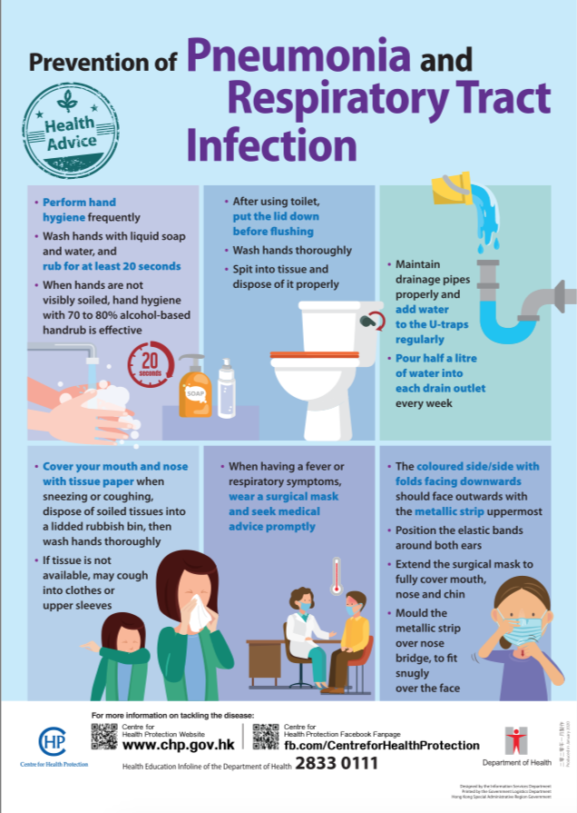
(https://www.chp.gov.hk/files/pdf/pneumonia_respiratory_health_advice_en.pdf)
Extracted from CHP, Department of Health
“COVID-19” website
https://www.coronavirus.gov.hk/eng/index.html
Questions：
- What is the main mode of transmission of “COVID-19”? Through respiratory __________.
- What are the main symptoms of “COVID-19”? _____________ and shortness of ___________.
- Where should we discard the used tissue paper? In a ____________ bin.
- If we have symptoms of“COVID-19” what should we do? Consult a ____________.

Answer Key:
D | B | P | W | A | L | S | R | S
G | R | D | R | B | L | R | A | A
A | E | O | U | I | I | H | T | D
R | A | C | P | O | D | A | E | T
T | T | T | T | L | D | R | Y | C
Y | H | O | A | F | E | V | E | R
U | A | R | K | P | D | T | R | M
J | T | Y | C | C | A | E | S | E
K | E | I | L | A | W | N | O | T

