Name: __________________________ ( ) Class: 5( )
Date : ___________________________

Interesting places in Hong Kong
Worksheet 1

- Preview the article. Here are some hints.

- Title and headings.
The title and headings tell me that this article is about
_______________________________________________________________.

- Can you find words printed in different ways? Circle the correct answer(s).
- boldface type b. underline c. different font d. others: ____________

- Can you find other clues from the article? Circle the correct answer(s).
- sidebars b. pictures c. tables d. maps e. others: ____________

- Contextual analysis tips
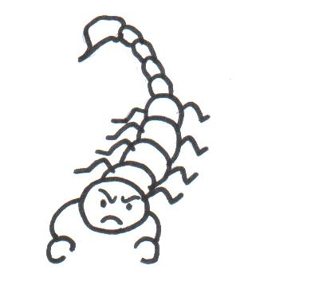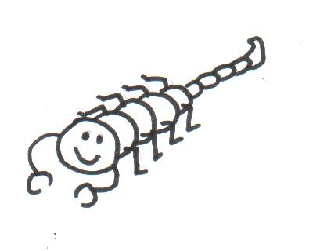
Picture clues:
The scorpion on the left is angry, and the one on the right is calm.

I used picture clues to learn the meaning of __________________________________

_____________________________________________________________________

_____________________________________________________________________

_____________________________________________________________________.

