(4) Template on Resource Planning [Plus ‘Resource Planner for IT in Education’ Excel file]

A template entitled ‘Resource Planner for IT in Education’ in an Excel file format is prepared for school for resource planning. The six-spreadsheet Resource Planner allows schools to systematically record details about income sources and expenditure breakdown in relation to the planning for school-based IT in education development. The following section is going to briefly introduce each spreadsheet in turn. Please refer to the captioned Excel file for more details.

- Spreadsheet 1 – ‘Introduction’:

The first spreadsheet is ‘Introduction’ (see Figure 1). This spreadsheet highlights the important aspects in resource planning for IT in education and provides a user guide to the use of the Resource Planner.

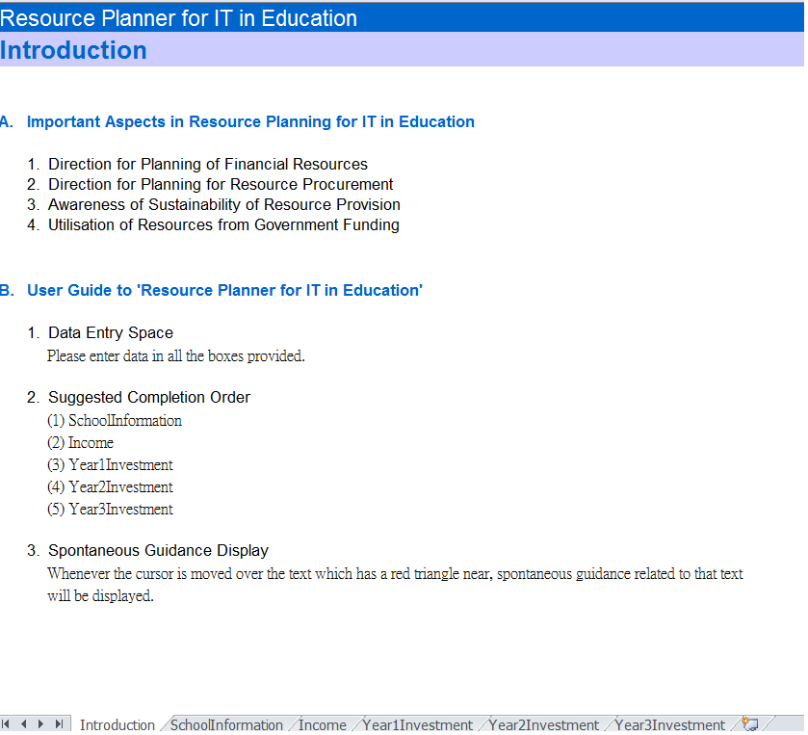
Figure 1: The interface of the spreadsheet ‘Introduction’
- Spreadsheet 2 – ‘SchoolInformation’:

The second spreadsheet is ‘SchoolInformation’ (see Figure 2). This spreadsheet allows schools to enter school details, including the numbers of class, student, staff and learning location, for an easy reference at a later stage in the development of school-based IT in education plan.
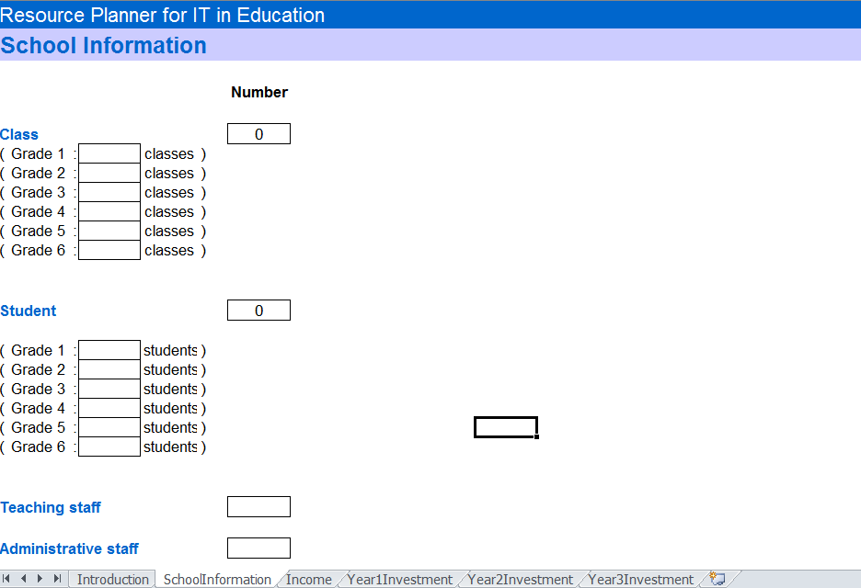
Figure 2: The interface of the spreadsheet ‘SchoolInformation’

- Spreadsheet 3 – ‘Income’:

The third spreadsheet is ‘Income’ (see Figure 3). This spreadsheet enables schools to enter financial information about school income concerning IT in education. Various types of financial resources related to IT in education, such as the relevant grants of IT in Education and the Quality Education Fund (QEF), are listed for schools’ consideration and completion accordingly.
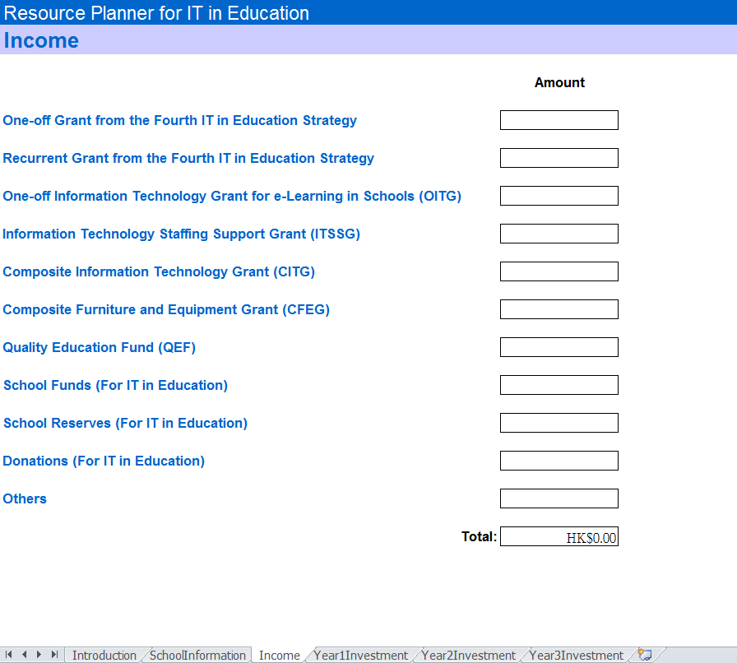
Figure 3: The interface of the spreadsheet ‘Income’
- Spreadsheet 4 – ‘Year1Investment’:

The fourth spreadsheet is ‘Year1Investment’ (see Figure 4). This spreadsheet allows schools to enter financial information about school budgets for the whole year of a one-year school-based IT in education development plan, or the first year of a three-year school-based IT in education development plan. Eight types of IT resources, including hardware, software, e-learning resources, networking technology, support services, relevant activities, assistive technology and consumable items, are enumerated for schools’ consideration. A list entitled ‘Others’ is also provided for schools to add further items of IT resources that are not included in the abovementioned eight standard lists.

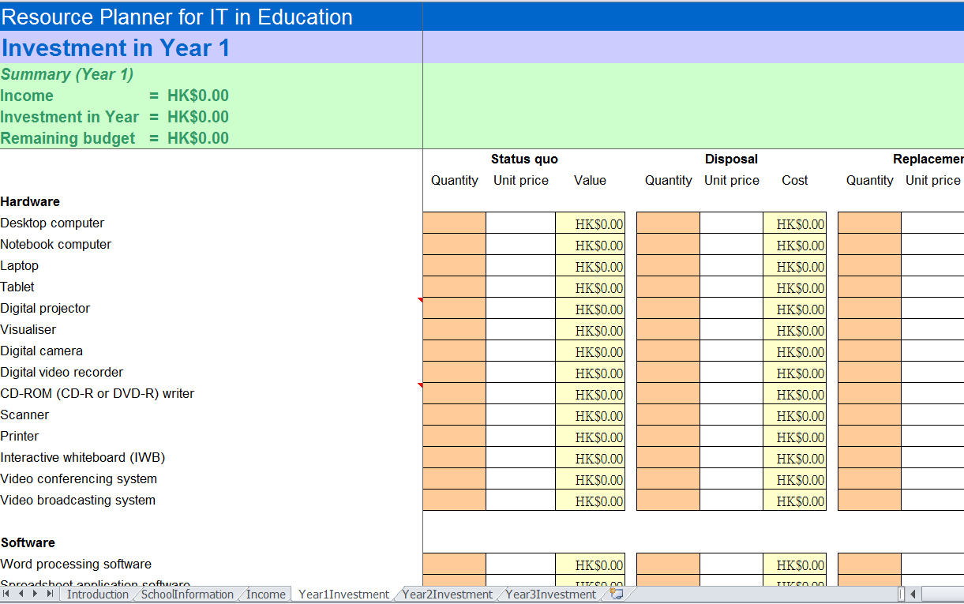
Figure 4: The interface of the spreadsheet ‘Year1Investment’

Users can enter the quantities and unit prices of individual IT resources which their schools currently possess; plan to retire; plan to replace; and plan to procure, during that year. The itemised costs and the total expenditure will be automatically generated based on the input data. In addition to these detailed financial information, a summary section on the financial status of that year is displayed in the top left-handed part of this spreadsheet. The total amounts of relevant income, investment in that year, and the remaining budget for future use can be quickly found by the users.

Spreadsheet 5 – ‘Year2Investment’:

The fifth spreadsheet is ‘Year2Investment’ (see Figure 5). This spreadsheet enables schools to enter financial information about school budgets for the second year of a three-year school-based IT in education development plan. The layout and content of this spreadsheet are identical to the ones in the spreadsheet ‘Year1Investment’, except both the total amount of investment in that year and the one of the previous year are displayed in the summary section for an easy comparison.
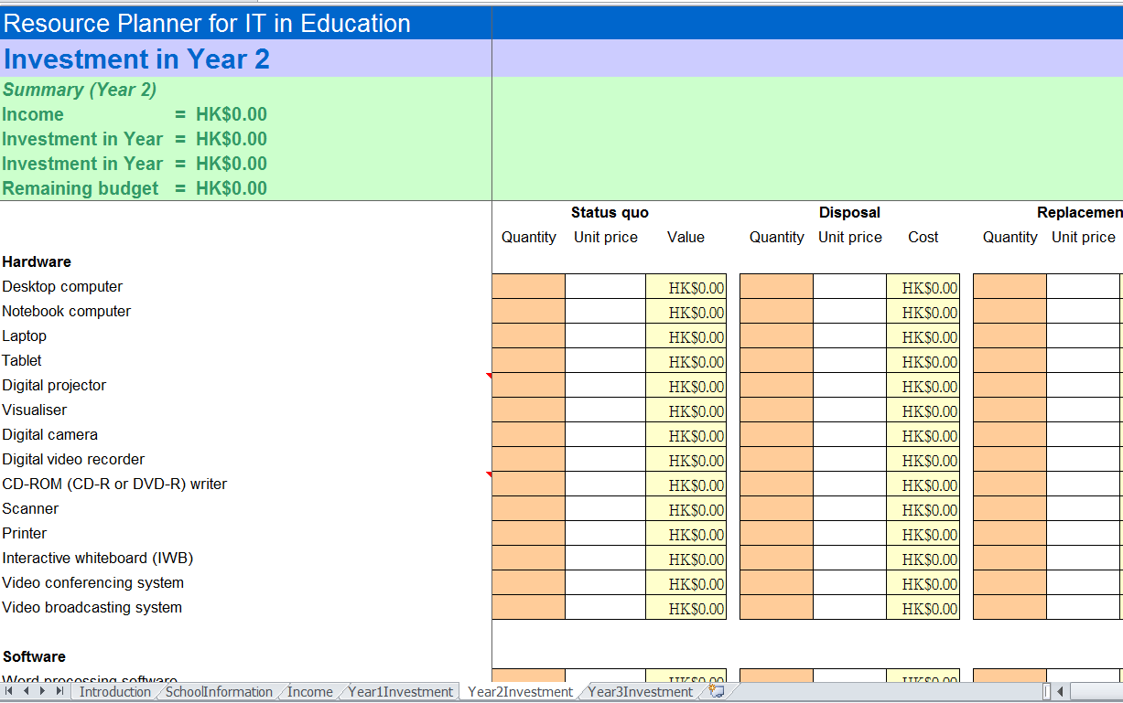
Figure 5: The interface of the spreadsheet ‘Year2Investment’

Spreadsheet 6 – ‘Year3Investment’:

The sixth spreadsheet is ‘Year3Investment’ (see Figure 6). This spreadsheet allows schools to enter financial information about school budgets for the final year of a three-year school-based IT in education development plan. The layout and content of this spreadsheet are identical to the ones in the spreadsheet ‘Year2Investment’, except the individual total amount of investment in these three years are separately displayed in the summary section for an easy comparison.

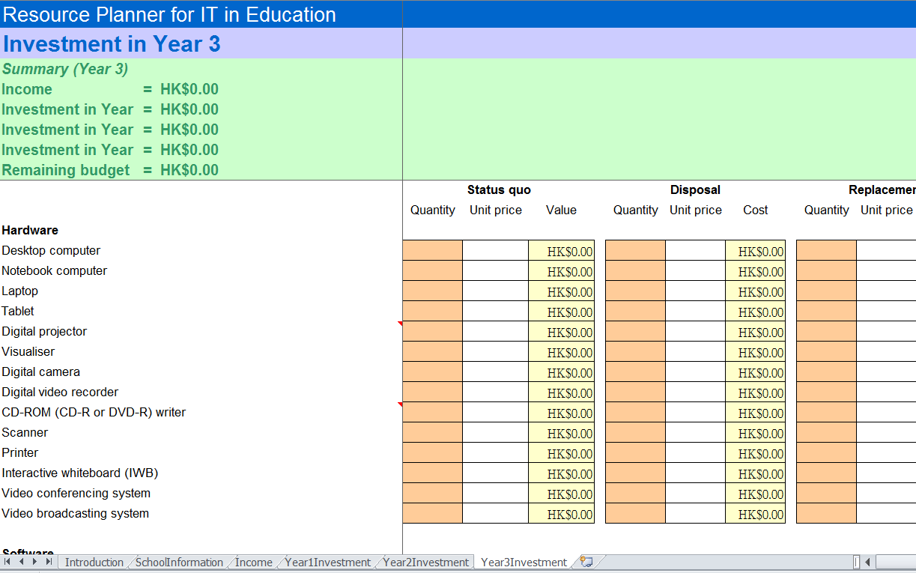
Figure 6: The interface of the spreadsheet ‘Year3Investment’

