Path to Moral Excellence
Personal Growth：Having Self-Respect
Cherish life; have a sense of shame; love oneself;
have self-respect; not to deceive oneself

Story：Stealing a Bell with Ears Plugged

- Learn from a Story
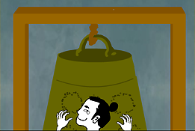 | 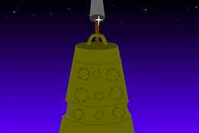
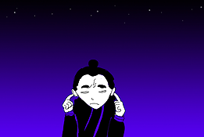 | 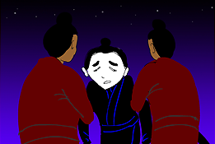
Story adapted from (Warring States Period) Chapter "Zi Zhi", Master Lu’s Spring and Autumn Annals (by Lu Buwei)

- Let Us Discuss
- 你認為故事中的小偷聰明嗎？為甚麼？
- 你有沒有做過或看見過別人做自欺欺人的事？試說出事情的經過和你的感受。
- 你認為自欺欺人的做法能不能夠解決問題？為甚麼？
- 假設你的朋友做出自欺欺人的行為，你會怎樣幫助他改過自新呢？

- Quotations from the Classics
河南省內鄉清代縣衙大堂對聯
The Couplet in the Hall in Neixiang County of Henan Province
欺人如欺天，毋自欺也；負民即負國，何忍負之？
(Cheating others is just like cheating god and the lie will eventually be discovered. So there is no point in deceiving anyone. Betraying people is just like betraying one’s country, and one will eventually lose his credit and honour. So how could we do that?)

《孟子‧離婁上》
Chapter "Li Lou 1", Mencius
夫人必自侮，然後人侮之。
(People who are insulted by others must have done something that caused that insult to take place.)

Original Text:
（孟子曰）「夫人必自侮，然後人侮之；家必自毀，而後人毀之；國必自伐，而後人伐之。《太甲》曰：『天作孽，猶可違；自作孽，不可活。』此之謂也。」

《周易‧益》
Chapter "Yi", The Book of Changes
君子以見善則遷，有過則改。
(Gentlemen will follow the good deeds they see and learn to behave equally well. They will also face up to their mistakes and correct them wholeheartedly.)

Original Text:
（益卦）《象》曰︰風雷，益；君子以見善則遷，有過則改。

Information: Master Lu's Spring and Autumn Annals Master Lu's Spring and Autumn Annals was the most complete classic of the Eclectic school that still exists in China. During the Warring States Period, Lu Buwei gathered his guests to finish the book. It is a book with the thinking of Confucianism and Taoism, which also adopted the theories of many different scholars. The basically complete set of theories provided a theoretical foundation for the establishment of the unified feudal empire for Qin. This book retained the plentiful information of over a hundred scholars in the Pre-Qin Period, including knowledge about astronomy, the calendar system, music, medicines, farming, etc. The book is an ancient encyclopedia that helps a lot in the academic study of the Pre-Qin Period.

