Path to Moral Excellence
Personal Growth：Having Self-Respect
Cherish life; have a sense of shame; love oneself;
have self-respect; not to deceive oneself

Story：Zhou Chu Corrected Himself

- Learn from a Story

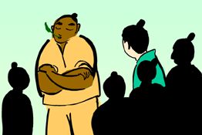
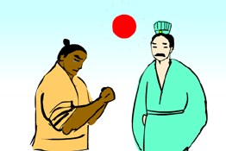
Story adapted from (Southern Dynasty) Chapter 15 "Zi Xin", New Anecdotes of Social Talk (by Liu Yiqing)

- Let Us Discuss
- 為甚麼周處那麼令人討厭呢？
- 你覺得周處是一個「知恥」的人嗎？為甚麼？
- 假如你是周處，知道大家都不喜歡你，你會怎麼辦？
- 假如你看見同學被人欺負，你會怎樣做呢？
- 你會不會接受一個改過自新的人呢？為甚麼？

- Quotations from the Classics
《禮記．中庸》
Chapter "Doctrine of the Mean", Classic of Rites
知恥近乎勇。
(People who have shame will be ashamed of their mistakes and will have to courage to correct themselves. They are truly courageous.)

Original Text:
子曰：「好學近乎知，力行近乎仁，知恥近乎勇。」

《左傳．宣公二年》
"The 2nd Year of Xuangong", Commentary of Zuo
人誰無過？過而能改，善莫大焉。
(Everyone makes mistakes. But nothing is better than knowing how to face up to one’s mistakes and correct them actively.)

Original Text:
晉靈公不君：厚斂以雕牆；從臺上彈人，而觀其辟丸也；宰夫胹熊蹯不熟，殺之，寘諸畚，使婦人載以過朝。趙盾 士季見其手，問其故，而患之。將諫，士季曰：「諫而不入，則莫之繼也。會請先，不入，則子繼之。」三進，及溜，而後視之，曰：「吾知所過矣，將改之。」稽首而對曰︰「人誰無過？過而能改，善莫大焉。《詩》曰︰「靡不有初，鮮克有終。」夫如是，則能補過者鮮矣。君能有終，則社稷之固也，豈惟群臣賴之。

（明）王守仁《教條示龍場諸生》
(Ming Dynasty) Jiao Tiao Shi Long Chang Zhu Sheng (by Wang Shouren)
不貴於無過，而貴於能改過。
(We cannot just avoid making mistakes. Instead, we should also learn from our mistakes, correct them and never make the same mistakes again.)

Information: New Anecdotes of Social Talk New Anecdotes of Social Talk, a collection of novels, is an iconic work of novels about people’s anecdotes during the Wei-Jin Period. It was written by Liu Yiqing of the Southern Dynasty and mainly recorded anecdotes of people with "Shizu" ranking at the period between the end of Eastern Han and Eastern Jin. Contents of the book could be classified under thirty-six categories including morality, politics and literature. It described the words and deeds of the famous people and scholars, which reflected the scholars’ thinking and the life of the upper class; it also criticised on quite a number of things about the dark side of the society and praised on the good points. New Anecdotes of Social Talk is a book with rich contents, refined wordings and talented ideas.

