Path to Moral Excellence
Personal Growth：Having Self-Respect
Cherish life; have a sense of shame; love oneself;
have self-respect; not to deceive oneself

Story：Sima Qian Treasured His Life

- Learn from a Story
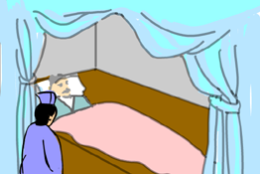 | 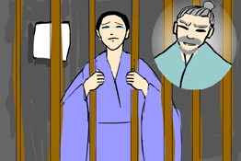
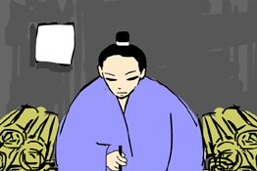 | 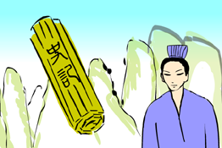
Story adapted from (Han Dynasty) The Self-preface of Tai Shi Gong, Records of the Grand Historian (by Sima Qian)

- Let Us Discuss
- 司馬遷受到重大屈辱後，是甚麼事情讓他放棄了自殺的念頭呢？
- 司馬遷珍惜生命，發憤圖強，結果他獲得了甚麼成就呢？
- 假如你的朋友受了挫折，自暴自棄，你會用甚麼方法幫助他恢復信心呢？
- 你嘗過失敗的滋味嗎？如果你跌倒了，你會怎樣重新站起來？
- 司馬遷説：「人固有一死，或重於泰山，或輕於鴻毛。」你認為怎樣的生命才有意義？

- Quotations from the Classics
（漢）司馬遷《報任安書》
(Han Dynasty) A Letter to Ren An (by Sima Qian)
人固有一死，或重於泰山，或輕於鴻毛。
(Human beings are mortal. But losing one’s life can be as significant as the mountain Taishan, or as insignificant as a feather of a wild goose.)

（晉）陳壽《三國志．魏書．梁習傳》，裴松之注
(Jin Dynasty) "Biography of Liang Xi", Book of Wei,
Records of the Three Kingdoms (by Chen Shou, edited by Pei Songzhi)
君子不為苟存，不為苟亡。
(Gentlemen would neither sacrifice their dignity in order to live a short while longer, nor would they end their own lives rashly.)

（唐）李白《比干碑》
(Tang Dynasty) Bigan Bei (by Li Po)
不可死而死是輕其生，非孝也；可死而不死，是重其死，非忠也。
(Choosing to end one’s life when one does not have to is an act of not valuing one’s life properly and it is not filial. Choosing to live cowardly when one should sacrifice one’s life is an act of valuing too much of one’s life and it is disloyal.)

Information: Records of the Grand Historian Records of the Grand Historian is one of the "25 dynastic histories" and is also the first book to present history in a series of biographies. The book, written by Sima Qian of the Western Han Dynasty, recorded history of more than two thousand years, from the years of Huangdi to the years of Emperor Wu of Han, and made a detailed record of the happenings during the Warring States Period, the Qing and the Han Dynasty. Contents of the book varied from political achievements of the emperors, track records of nobles and feudal princes, social policies and natural phenomenon and descriptions of people from all walks of life. The lists of big events of the year assisted readers to look up historic facts and the postscript section that commented on some historical figures and happenings served as a reference for the later generations. The whole book is covered with comprehensive information delivered in a refined style and outstanding evaluation.

