Path to Moral Excellence
Personal Growth：Having Self-Control
Not to become materialistic;
not to be emotionally unrestrained

Story：Hedonism Weakens the Will

- Learn from a Story
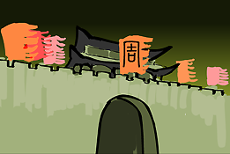 | 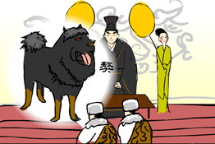
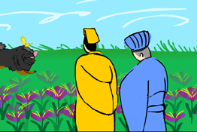 | 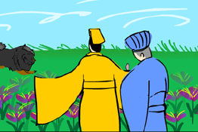
Story adapted from Chapter "Lu Ao", Book Zhou, Book of Documents

- Let Us Discuss
- 為甚麼召公認為玩弄物品會令人喪失志氣？
- 假如你得到了一件渴望已久的玩具，你認為怎樣做才不致於變得玩物喪志呢？
- 你有沒有曾經因為沉迷玩樂而影響學業成績？試說出你的經驗和感受。
- 試舉出現實生活中一些因沉迷玩樂而帶來害處的例子。
- 試為自己設計一個「學習與娛樂」的時間表，並加以實行。

- Quotations from the Classics
《尚書．周書．旅獒》
Chapter "Lu Ao", Book Zhou, Book of Documents
玩人喪德，玩物喪志。志以道寧，言以道接。
(Humiliating and cheating people will cause one to lose one’s virtue; indulging in pleasures will cause one to lose spirit. On the right way, one will have peace in one’s spirit and aspiration, and one’s words and deeds will also be accepted by everyone.)

Original Text：
西旅獻獒，太保作《旅獒》。惟克商，遂通道於九夷八蠻。西旅厎貢厥獒，太保乃作《旅獒》，用訓於王。曰：「嗚呼！明王慎德，西夷鹹賓。無有遠邇，畢獻方物，惟服食器用。王乃昭德之致於異姓之邦，無替厥服；分寶玉於伯叔之國，時庸展親。人不易物，惟德其物！德盛不狎侮。狎侮君子，罔以盡人心；狎侮小人，罔以盡其力。不役耳目，百度惟貞。玩人喪德，玩物喪志。志以道寧，言以道接。不作無益害有益，功乃成；不貴異物賤用物，民乃足。犬馬非其土性不畜，珍禽奇獸不育於國，不寶遠物，則遠人格；所寶惟賢，則邇人安。嗚呼！夙夜罔或不勤，不矜細行，終累大德。為山九仞，功虧一簣。允迪茲，生民保厥居，惟乃世王。」

（晉）桓範《政要論．節欲》
(Jin Dynasty) Chapter "Jie Yu", Zheng Yao Lun (by Huan Fan)
放情者危，節欲者安。
(Indulging in lust and pleasures is extremely dangerous. Only those who can control and limit themselves can have a peaceful mind.)
《管子．內業》
Chapter "Nei Ye", Guanzi
節欲之道，萬物不害。
(The only way to control one’s desire is try not to harm anything in nature.)

Information: Book of Documents Book of Documents is the earliest history writing in China and is also one of the five great classics in Confucianism. It stated history from the years of Yaoshun to the Middle Spring and Autumn Period and people inferred that authors of this book were officials at this period of time. The contents were mainly imperial documents and records of conversation between the emperors and their subordinates. Book of Documents is the first compilation of historic political materials. It not only helps the later generations broaden their knowledge of the ancient society, but is also worth a lot in the study of language development. Original Text： 惟克商，遂通道於九夷八蠻。西旅厎貢厥獒，太保乃作《旅獒》，用訓於王。曰：「嗚呼！明王慎德，西夷鹹賓。無有遠邇，畢獻方物，惟服食器用。王乃昭德之致於異姓之邦，無替厥服；分寶玉於伯叔之國，時庸展親。人不易物，惟德其物！德盛不狎侮。狎侮君子，罔以盡人心；狎侮小人，罔以盡其力。不役耳目，百度惟貞。玩人喪德，玩物喪志。志以道寧，言以道接。不作無益害有益，功乃成；不貴異物賤用物，民乃足。犬馬非其土性不畜，珍禽奇獸不育於國，不寶遠物，則遠人格；所寶惟賢，則邇人安。嗚呼！夙夜罔或不勤，不矜細行，終累大德。為山九仞，功虧一簣。允迪茲，生民保厥居，惟乃世王。」

