Path to Moral Excellence
Personal Growth：Having Self-Control
Not to become materialistic;
not to be emotionally unrestrained

Story：Fan Zhongyan was Satisfied with a Simple Life

- Learn from a Story
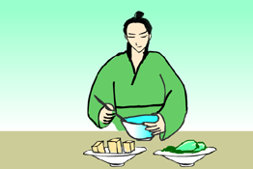 | 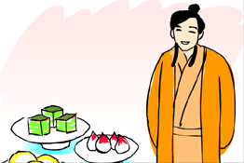
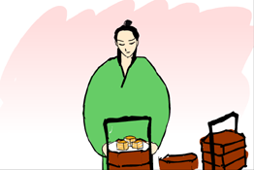

Story adapted from (Yuan Dynasty) Biography of Fan Zhongyan, The History of Song Dynasty (by Toktoghan)

- Let Us Discuss
- 你覺得范仲淹甘於刻苦清貧的生活跟他後來在文學和政治上的成就有關係嗎？請加以說明。
- 「由儉入奢易，由奢入儉難」這句話是甚麼意思？試解釋一下。
- 生活勤儉和自我節制有甚麼好處？試舉例子說明。
- 在現今的社會中，你認為怎樣的生活才是有節制的生活？試舉例子。

- Quotations from the Classics
（宋）司馬光《訓儉示康》
(Song Dynasty) Xun Jian Shi Kang (by Sima Guang)
由儉入奢易，由奢入儉難。
(It is always easy to get used to a luxurious life after living a frugal life, but not vice versa。)

（宋）司馬光《資治通鑒．唐紀》
(Song Dynasty) Chapter "Tang Ji",
Comprehensive Mirror for Aid in Government (by Sima Guang)
取之有度，用之有節，則常足。
(You will be fully contented if you can control your consumption of the resources. )

（宋）司馬光《資治通鑒．梁紀》
(Song Dynasty) Chapter "Tang Ji",
Comprehensive Mirror for Aid in Government (by Sima Guang)
儉約，所以彰其美也。
(One will become more respectable if one lives a frugal life. )

Information：The History of Song Dynasty The History of Song Dynasty, one of the "25 dynastic histories", was compiled by Toktoghan and others during the final years of the Yuan Dynasty. It is about the three hundred and twenty years of history of the Song Dynasty, including achievements of the emperors, social policies and natural phenomenon, records of big events in the past, description on people with different social status; and the relationships between Liao, Xia, Jin and Yuan. It is the book with the richest contents amongst the 25 dynastic histories. The voluminous work and its detailed descriptions gave the book a high academic value.

