Path to Moral Excellence
Personal Growth：Being Realistic and Practical
Accept facts; respect evidence; dare to explore

Story：Bian Que Cured the Dying Prince

- Learn from a Story

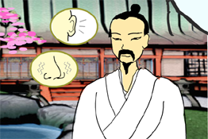 | 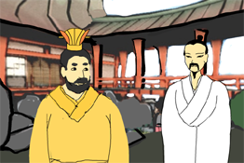
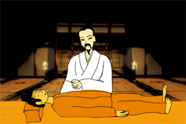 | 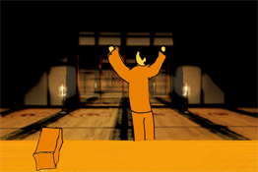
Story adapted from (Han Dynasty) Biographies of Bian Que and Cang Gong, Records of the Grand Historian (by Sima Qian)

- Let Us Discuss
- 你認為扁鵲是一個實事求是的人嗎？何以見得？
- 遇上困難，如像虢人一樣，只管求神問卜，你覺得這樣做可以解決問題嗎？為甚麼？
- 在學習上，怎樣才是實事求是的態度？
- 在專題研習中，同學提出了不同的意見，如果你是組長，你會怎樣做？

- Quotations from the Classics
（清）周希陶《增廣賢文》
(Qing Dynasty) Essays on Ancient Chinese Wisdom (by Zhou Xitao)
過則無憚改，獨則無自欺。
(Do not hesitate to correct any mistake. Act according to conscience even if one is alone.)

《論語‧為政第二》
Chapter 2 "The Secret in Government", The Analects
知之為知之，不知為不知，是知也。
(It is true wisdom for one to acknowledge honestly what one knows and what one does not know.)

Original Text：
子曰：「由，誨女知之乎！知之為知之，不知為不知，是知也。」

（唐）盧鉟《勖曹生》
(Tang Dynasty) Xu Cao Sheng (by Lu Pi)
莫為狂花迷眼界，需求真理定心王。
(Never let vain hopes and evil thoughts perplex our knowledge and vision. Let us seek truth to enrich our wisdom.)

Information：Records of the Grand Historian Records of the Grand Historian is one of the "25 dynastic histories" and is also the first book to present history in a series of biographies. The book, written by Sima Qian of the Western Han Dynasty, recorded history of more than two thousand years, from the years of Huangdi to the years of Emperor Wu of Han, and made a detailed record of the happenings during the Warring States Period, the Qing and the Han Dynasty. Contents of the book varied from political achievements of the emperors, track records of nobles and feudal princes, social policies and natural phenomenon and descriptions of people from all walks of life. The lists of big events of the year assisted readers to look up historic facts and the postscript section that commented on some historical figures and happenings served as a reference for the later generations. The whole book is covered with comprehensive information delivered in a refined style and outstanding evaluation.

