Path to Moral Excellence
Personal Growth：Being Realistic and Practical
Accept facts; respect evidence; dare to explore

Story：Song Ci the Forensic Judge

- Learn from a Story
 | 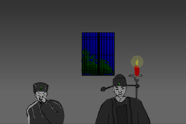
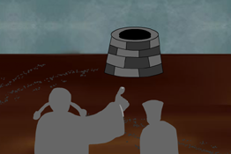 | 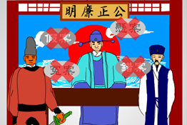
Story adapted from (Song Dynasty) Collected Cases of Injustice Rectified through Forensic Science (by Song Ci)

- Let Us Discuss
- 原以為李四一案會就此了結，是甚麼令宋慈翻查案件，找出真兇？
- 宋慈和師爺的辦案手法各有甚麼不同？你較為欣賞哪一種？為甚麼？
- 你認為自己在處事態度上，比較像師爺還是宋慈？試舉例說說自己的經驗和感受。
- 在日常的學習中，如果你對課本的內容有懷疑，你會怎樣做？

- Quotations from the Classics
《禮記‧中庸》
Chapter "Doctrine of the Mean", Classic of Rites
博學之，審問之，慎思之，明辨之，篤行之。
(The ways to acquire knowledge are learning broadly, investigating thoroughly, thinking carefully, differentiating clearly and implementing faithfully.)

Original Text：
誠之者，擇善而固執之者也。博學之，審問之，慎思之，明辨之，篤行之。有弗學，學之弗能，弗措也。

（唐）張九齡《敕安西節度王斛斯書》
(Tang Dynasty) Chi Anxi Jiedu Wang Husi Shu (by Zhang Jiuling)
未知事實，不可虛行。
(Never jump to any conclusion before sorting out the facts.)

（漢）王充《論衡．薄葬》
(Han Dynasty) Chapter "Bao Zang ", Lun Heng (by Wang Chong)
事莫明於有效，論莫定於有證。
(The best way to check the authenticity of a matter is to see if it is effective; the best way to check the credibility of a theory is to see if it has any proof.)

Information：Collected Cases of Injustice Rectified through Forensic Science Collected Cases of Injustice Rectified through Forensic Science, the first monograph of forensic science in China, is the first book about systematic judicial inspection in the world. It was written by Song Ci of the Song Dynasty, and was finished in 1247. It gave exposition to aspects in physiology, drugs, diagnosis, treatment, prevention, first-aid, autopsy, etc. Within the five hundred years after the publishing of this book, it was a must-have reference book for the judicial officials. Nowadays, many of the contents are still used as reference. This book was circulated outside China and was translated into different languages, including English, French, Dutch, German, Korean, Japanese and Russian. It shows that Collected Cases of Injustice Rectified through Forensic Science has a influential position in the world history of forensic science.

