Path to Moral Excellence
Personal Growth：Being Serious and Responsible
Be responsible; not to do things perfunctorily;
do something to atone for the mistakes made before

Story：Leaving Money for the Dates Eaten

- Learn from a Story

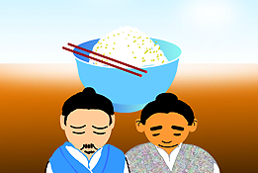 | 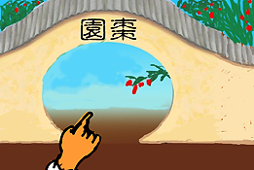
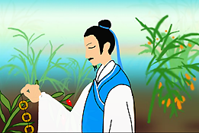 | 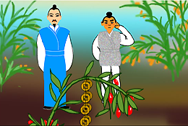
Story adapted from (Yuan Dynasty) Biography of Zha Dao, The History of Song Dynasty (by Toktoghan)

- Let Us Discuss
- 就故事中所見，查道是一個怎樣的人？何以見得？
- 你認為查道最值得別人稱頌的是甚麼？你有沒有這種美德？請和同學分享一下。
- 名句說：「人生須知道負責任的苦處，才能知道有盡責任的樂處」，你同意這句話嗎？為甚麼？
- 日常生活中，你認為怎樣才是一個認真負責的人？試舉例子說明。

- Quotations from the Classics
（明）王守仁《教條示龍場諸生》
(Ming Dynasty) Jiao Tiao Shi Long Chang Zhu Sheng (by Wang Shouren)
夫過者，自大賢所不免；然不害其卒為大賢者，為其能改也。故不貴於無過，而貴於能改過。
(Even virtuous people make mistakes. But those mistakes do not affect their virtuousness, since they will correct their mistakes. Therefore, we should not focus merely on the mistakes that people have made, instead we should care more if they have corrected their mistakes or not.)

（現代）梁啟超《最苦與最樂》
(Modern Times) The Hardest and the Happiest (by Liang Qichao)
人生須知道負責任的苦處，才能知道有盡責任的樂處。
(One should understand the bitterness of undertaking responsibility before knowing the pleasure of fulfilling it.)

（清）魏源《默觚．治篇》
(Qing Dynasty) Chapter "Zhi", Mo Gu (by Wei Yuan)
君子用世，隨大隨小，皆全力赴之。
(When gentlemen are entrusted with duties, they will try their best in anything they do, be it important or trivial.)

Information: The History of Song Dynasty The History of Song Dynasty, one of the "25 dynastic histories", was compiled by Toktoghan and others during the final years of the Yuan Dynasty. It is about the three hundred and twenty years of history of the Song Dynasty, including achievements of the emperors, social policies and natural phenomenon, records of big events in the past, description on people with different social status; and the relationships between Liao, Xia, Jin and Yuan. It is the book with the richest contents amongst the 25 dynastic histories. The voluminous work and its detailed descriptions gave the book a high academic value.

