Path to Moral Excellence
Personal Growth：Being Serious and Responsible
Be responsible; not to do things perfunctorily;
do something to atone for the mistakes made before

Story：Selfless "Great Yu" Accomplished the Flood Control Mission

- Learn from a Story
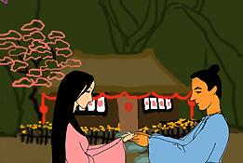 | 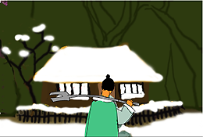
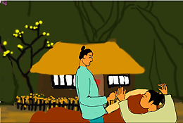 | 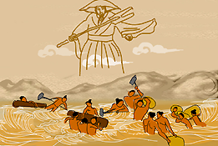
Story adapted from (Han Dynasty) The History of the Xia Dynasty, Records of the Grand Historian (by Sima Qian)

- Let Us Discuss
- 大禹因治水的緣故，三過家門而不入，我們從他身上學到甚麼？
- 在當時的環境之下，禹應該爭分奪秒去治水，還是應該留些時間探望家人？試說說你的意見。
- 今天，媽媽想帶你到迪士尼樂園遊玩，但你忽然想起已經約了同學做專題研習，你會怎樣選擇？為甚麼？
- 你是認真負責的人嗎？試舉一個生活實例說明。
- 請從實際生活中舉出一個「因公忘私」的實例。

- Quotations from the Classics
（漢）班固《漢書．賈誼傳》
(Han Dynasty) "Biography of Jia Yi", Book of Han (by Ban Gu)
主耳忘身，國耳忘家，公耳忘私，利不苟就，害不苟去，唯義所在。
(Forget your personal interest for the sake of your master. Put the country above your family. Forget your personal interest for the sake of public interest. Do not act incautiously for benefits, and do not give up rashly just because the action may cause some harm. These are the principles of justice.)

（漢）班固《漢書．賈山傳》
(Han Dynasty) "Biography of Jia Shan", Book of Han (by Ban Gu)
不能盡其心，則不能盡其力；不能盡其力，則不能成其功。
(If you cannot put your heart and soul into what you do, you can never do your best. If you cannot do your best, you can never accomplish anything.)

（唐）韓愈《為裴相公讓官表》
(Tang Dynasty) Wei Pei Xiang Gong Rang Guan Biao (by Han Yu)
苦心焦思，以日繼夜，苟利於國，知無不為。
(One should put one’s heart and soul day and night to do things that are beneficial to the country.)

Information: Records of the Grand Historian Records of the Grand Historian is one of the "25 dynastic histories" and is also the first book to present history in a series of biographies. The book, written by Sima Qian of the Western Han Dynasty, recorded history of more than two thousand years, from the years of Huangdi to the years of Emperor Wu of Han, and made a detailed record of the happenings during the Warring States Period, the Qing and the Han Dynasty. Contents of the book varied from political achievements of the emperors, track records of nobles and feudal princes, social policies and natural phenomenon and descriptions of people from all walks of life. The lists of big events of the year assisted readers to look up historic facts and the postscript section that commented on some historical figures and happenings served as a reference for the later generations. The whole book is covered with comprehensive information delivered in a refined style and outstanding evaluation.

