Path to Moral Excellence
Personal Growth：Being Serious and Responsible
Be responsible; not to do things perfunctorily;
do something to atone for the mistakes made before

Story：Sun Wu Trained the Female Soldiers

- Learn from a Story
 | 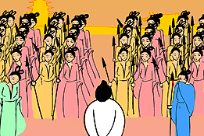
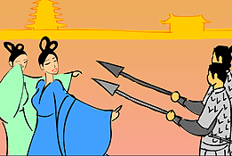 | 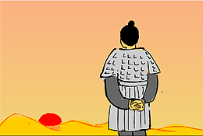
Story adapted from (Han Dynasty) Biographies of Sun Zi and Wu Qi, Records of the Grand Historian (by Sima Qian)

- Let Us Discuss
- 為甚麼孫武在模擬演練中處決兩名吳王的寵妃呢？他不怕開罪吳王嗎？這件事反映出孫武的為人怎樣？
- 試說說孫武處決兩個女兵隊長前後，女兵們的態度有甚麼不同？
- 如果士兵平日練習時不認真，日後作戰會有甚麼後果？
- 假如你是孫武，除了殺一儆百之外，還有更好的方法使這班女兵認真地接受訓練嗎？
- 當你發現做事有缺失時，你會立即主動修正嗎？為甚麼？

- Quotations from the Classics
（戰國）韓非子《韓非子．有度第六》
(Warring Dynasty) Chapter 6 "You Du", Han Fei Zi (by Han Fei Zi)
奉法者強則國強，奉法者弱則國弱。
(A country will become powerful when law and order are executed effectively, and it will be weakened if this is not the case.)

《禮記．表記》
Chapter "Biaoji", Classic of Rites
處其位而不履其事，則亂也。
(Society will be in chaos if people fail to undertake the responsibilities of their positions.)

Original Text：
子曰：「事君，軍旅不辟難，朝廷不辭賤。處其位而不履其事，則亂也。故君使其臣，得志則慎慮而從之，否則孰慮而從之，終事而退，臣之厚也。《易》 曰：『不事王侯，高尚其事。』」

《春秋穀梁傳．僖公十六年》
"The 16th year of Xi Gong",
Spring and Autumn Annals-The Guliang Commentary
君子之於物；無所苟而已。
(Gentlemen never act hastily and thoughtlessly.)

Original Text：
君子之於物；無所苟而已。

Information: Records of the Grand Historian Records of the Grand Historian is one of the "25 dynastic histories" and is also the first book to present history in a series of biographies. The book, written by Sima Qian of the Western Han Dynasty, recorded history of more than two thousand years, from the years of Huangdi to the years of Emperor Wu of Han, and made a detailed record of the happenings during the Warring States Period, the Qing and the Han Dynasty. Contents of the book varied from political achievements of the emperors, track records of nobles and feudal princes, social policies and natural phenomenon and descriptions of people from all walks of life. The lists of big events of the year assisted readers to look up historic facts and the postscript section that commented on some historical figures and happenings served as a reference for the later generations. The whole book is covered with comprehensive information delivered in a refined style and outstanding evaluation.

