Path to Moral Excellence
Personal Growth：Being Determined and Diligent
Keep working hard; never give up one’s goal
Story：Liang Hao Succeeded in His Old Age

- Learn from a Story
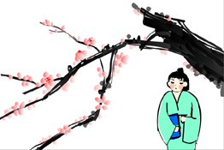 | 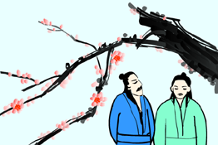
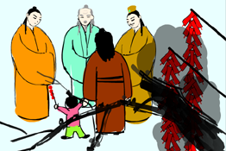 | 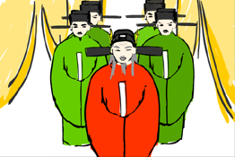
Story adapted from (Song Dynasty) Three Character Classic (by Wang Yinglin)

- Let Us Discuss
- 是甚麼原因驅使梁灝屢敗屢試呢？
- 假如你是梁灝，多次未能考中狀元，你會有甚麼感受？你會放棄嗎？
- 有人認為梁灝過於固執，也有人認為他十分堅毅，你有甚麼看法？
- 你試過憑着毅力達成自己的心願嗎？試分享一下。
- 「大器晚成」這句話是甚麼意思？這句話是用來鼓勵哪些人的呢？

- Quotations from the Classics
（清）周希陶《增廣賢文》
(Qing Dynasty) Essays on Ancient Chinese Wisdom (by Zhou Xitao)
但行好事，莫問前程。鈍鳥先飛，大器晚成。
(We just keep on doing good things and need not worry too much about the outcome. Stupid birds fly away early, since they do not want to lag behind other birds. However, people who have great achievements usually succeed later because great achievements take time and a lot of efforts. Since these people never give up their ideals, they will strive very hard until they finally reach their goal.)

《禮記．中庸》
Chapter "Doctrine of the Mean", Classic of Rites
人一能之，己百之；人十能之，己千之。果能此道矣，雖愚必明，雖柔必強。
(If people succeed with one attempt, I will take a hundred attempts. If people succeed with ten attempts. I will take a thousand attempts. With such an approach, even if I am stupid and weak at the beginning, I will become clever and strong eventually.)

Original Text：
（孔子曰）「誠者，天之道也；誠之者，人之道也。誠者，不勉而中，不思而得，從容中道，聖人也。誠之者，擇善而固執之者也。博學之，審問之，慎思之，明辨之，篤行之。有弗學，學之弗能弗措也。有弗問，問之弗知弗措也；有弗思，思之弗得弗措也；有弗辨，辨之弗明弗措也。有弗行，行之弗篤弗措也。人一能之，己百之；人十能之，己千之。果能此道矣，雖愚必明，雖柔必強。」

（清）彭端淑《為學一首示子侄》
(Qing Dynasty) Wei Xue Yi Shou Shi Zi Zhi (by Peng Duanshu)
旦旦而學之，久而不怠焉，迄乎成。
(You will succeed eventually if you can persist in studying and do not slack off.)

Information: Three Character Classic Wang Yinglin of the Song Dynasty was believed to be the author of Three Character Classic. The book was written with rhymed language in three characters which made it easy to read out and memorise, so as to facilitate an easier understanding. Although there were not many characters in the book, it did cover a wide range of things, such as astronomy, geography, history, personality and moral education. It was a popular enlightening textbook in the old days and allowed readers to acquire knowledge as well as to build up a positive value of life.

