Path to Moral Excellence
Personal Growth：Being Determined and Diligent
Keep working hard; never give up one’s goal

Story：The Light Beam from the Hole in the Wall

- Learn from a Story
 | 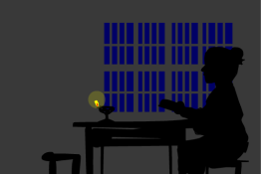
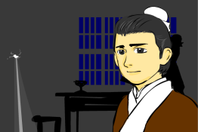 | 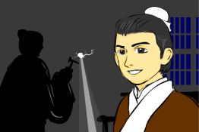
Story adapted from Volume 2, Miscellaneous Records of the Western Capital

- Let Us Discuss
- 匡衡用了哪些方法爭取更多看書的機會？
- 你認為匡衡「鑿壁偷光」的做法對嗎？為甚麼？請你提議更好的方法給他。
- 假設你是故事中的富翁或鄰居，你會怎樣幫助匡衡呢？
- 你同意「業精於勤，荒於嬉」這句話嗎？試說出相關的經歷和感受。
- 試蒐集一些因勤奮堅毅而成功的名人資料，然後向同學匯報。

- Quotations from the Classics
（漢）徐幹《中論．治學》
(Han Dynasty) Chapter "Zhi Xue", Zhong Lun (by Xu Gan)
日習則學不忘，自勉則身不墮。
(If you endeavor to learn, you will never forget the knowledge that you have learnt. If you keep on encouraging yourself, you will not slack off easily.)

（唐）韓愈《進學解》
(Tang Dynasty) The Scholars Apologia (by Han Yu)
業精於勤，荒於嬉。
(One’s studies will become proficient if one works hard, but they will also be dropped if one indulges in playing and enjoyment.)

（清）宋纁《古今藥石．續自警編》
(Qing Dynasty) Chapter "Xu Zi Jing", Gu Jin Yao Shi (by Song Xun)
民生在勤，勤而不匱，是勤可以免飢寒也。
(The best way to sustain one’s living is to work hard. One should work hard for food and shelter and stay away from poverty.)

Information: Miscellaneous Records of the Western Capital Miscellaneous Records of the Western Capital, a collection of history novels, is a book about anecdotes happened during the Western Han Dynasty. The history of the Western Han Dynasty, folk customs and ideas could be found in the book. This book also stated the life in the imperial gardens, some literary works, funny stories in the literary circles and anecdotes of writers, together with some strange legends. It is a book with record of trifles, neatly-presented contents and lively narration.

