Path to Moral Excellence
Personal Growth：Being Dedicated in What One Does

Story：Two Students Learning to Play Chess Together

- Learn from a Story
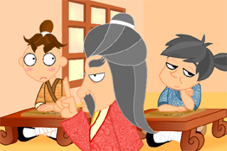 | 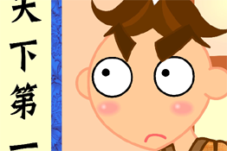
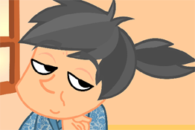 | 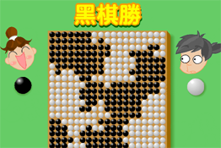
Story adapted from Chapter "Gao Zi 1", Mencius
- Let Us Discuss
- 為甚麼學生乙學弈不能成功？
- 上課不專心會有甚麼後果？
- 你覺得甚麼事情會阻礙你專心上課？可以怎樣克服呢？
- 如果同學上課時不專心，只顧談話，你會怎樣做呢？
- 你認為在求學時，除了專心致志之外，還要怎麼做？

- Quotations from the Classics
《孟子‧告子上》
Chapter "Gao Zi 1", Mencius
今夫弈之為數，小數也；不專心致志，則不得也。
(Playing chess may be a tiny skill. But if you do not try your best, you will not play it well.)

Original Text：
孟子曰：「無或乎王之不智也，雖有天下易生之物也，一日暴之，十日寒之。未有能生者也。吾見亦罕矣，吾退而寒之者至矣。吾如有萌焉何哉！今夫弈之為數，小數也；不專心致志，則不得也。弈秋，通國之善弈者也。使弈秋誨二人弈，其一人專心致志，惟弈秋之為聽。一人雖聽之，一心以為有鴻鵠將至，思援弓繳而射之，雖與之俱學，弗若之矣。為是其智弗若與？曰：非然也。」

（宋）林逋《省心錄》
(Song Dynasty) Xing Xin Lu (by Lin Bu)
用心專者，不聞雷霆之震驚，寒暑之切肌。
(When one is totally absorbed in his work, he can be so concentrated that he will not notice how striking the thunder is or how cold or hot the weather is.)

《禮記．中庸》
Chapter "Doctrine of the Mean", Classic of Rites
君子遵道而行。半塗而廢，吾弗能已矣。
(Gentlemen’s actions are all based on the right way. It will not be possible for me to give up half-way or violate the right way.)

Original Text：
子曰：「素隱行怪，後世有述焉，吾弗為之矣。君子遵道而行，半塗而廢，吾弗能已矣。君子依乎中庸，遯世不見知而不悔，唯聖者能之。」

Information: Mencius Mencius records the thinking and discourse of Mengzi. It has the reputation of being a classic work of Confucianism. Mengzi followed the thought of "humanity" proposed by Confucius, suggested the theory of inborn kindheartedness and promoted the ideas of a benevolent government. He also supported that the people are more important than the ruler. Mencius is famous of its argumentative essays, with strong reasoning, sharp wordings and interesting metaphors, which leaves prominent influence to the later generations. Original Text： 孟子曰：「無或乎王之不智也，雖有天下易生之物也，一日暴之，十日寒之。未有能生者也。吾見亦罕矣，吾退而寒之者至矣。吾如有萌焉何哉！今夫弈之為數，小數也；不專心致志，則不得也。 弈秋，通國之善弈者也。使弈秋誨二人弈，其一人專心致志，惟弈秋之為聽。一人雖聽之，一心以為有鴻鵠將至，思援弓繳而射之，雖與之俱學，弗若之矣。為是其智弗若與？曰：非然也。」

