Path to Moral Excellence
Personal Growth：Being Dedicated in What One Does

Story：The Old Cicada Catcher

- Learn from a Story
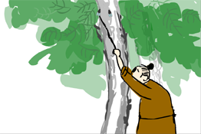 | 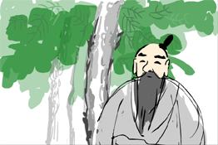
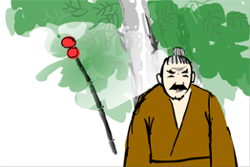 | 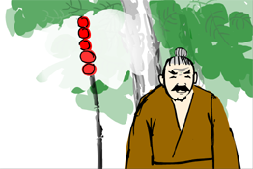
Story adapted from Chapter "Da Sheng", Book "Wai Bian", Chuang Tsu

- Let Us Discuss
- 捕蟬駝翁為甚麼要利用圓球和竹竿來訓練捕蟬的技能？
- 你試過專心致志地做一件事情嗎？結果怎樣呢？請跟大家分享你的經驗。
- 你認為捕蟬駝翁對捕蟬的工作態度是「敬業」嗎？為甚麼？
- 你認為學習環境會影響你的專注力嗎？如果學習環境不理想，可以怎樣克服呢？

- Quotations from the Classics
（清）曾國藩《致沅弟．咸豐七年十二月十四夜》
(Qing Dynasty) To brother Yuan, 14th Night of the Twelfth Lunar Month in Xianfeng Year Seven (by Zeng Guofan)
凡人作一事，便須全副精神注在此一事。首尾不懈，不可見異思遷，做這樣想那樣，坐這山望那山。人而無恆，終身一無所成。
(When one sets out to do something, one should concentrate on it. Never start off with a bang but end up with a whimper. One should never lose one’s mind and concentration. One should never distract one’s mind on another thing while doing this thing at hand, just like sitting on one mountain but keeping an eye watching another mountain. One will have no achievement if one fails to persevere in what one does. )

（唐）張鷟《遊仙窟》
(Tang Dynasty) Travelling in Fairy Cave (by Zhang Zhuo)
心欲專，鑿石穿。
(If you can concentrate, you may even be able to pierce through a stone. This metaphor means that when one has a strong will, one can accomplish anything.)

《莊子．外篇．達生》
Chapter "Da Sheng", Book "Wai Bian", Chuang Tzu
用志不分，乃凝於神。
(Everything goes smoothly as if helped by the providence if one can concentrate without being distracted.)

Information: Chuang Tsu Chuang Tsu, a collection of writings by the Zhuangzi school of thinking and a weighty classic in Taoism, recorded Zhuangzi’s thinking and discourse. The whole book contained Nei Pian, Wai Pian and Za Pian. People generally believed that Nei Pian was written by Zhuangzi himself and the rest were composed by his disciples and followers. This book made good use of fables and metaphors to explain philosophic theories. Together with the elegant wordings, the book is definitely a great work in literature. Remark： During the ancient time, a common method to catch a cicada was to tie a spider thread on at one end of a bamboo pole. Then the catcher held the pole under a tree while looking for a cicada. If he spotted one, he then stuck the thread of the pole to the cicada's wings stealthily. In doing so, the pole had to be steady. Otherwise, the cicada would notice and fly away.

