Path to Moral Excellence
Personal Growth：Being Active and Enterprising
Follow a high standard; try one’s best


Story：Visiting a Teacher Thousands of Miles Away

- Learn from a Story
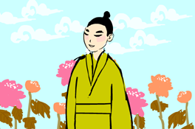 | 
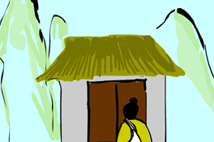 | 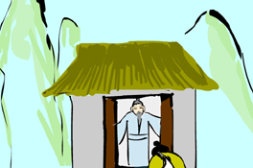
Story adapted from (Southern Dynasty) The Biography of Li Du, Book of the Later Han (by Fan Ye)

- Let Us Discuss
- 李固為甚麼要到遠方拜老先生為師呢？
- 如果你想學習一些比較專門的知識或技能，例如：電腦繪圖，你會怎樣做呢？
- 假如你學習一門技能，已經有相當不錯的成績，例如：彈鋼琴，你還會花時間去進一步鑽研嗎？為甚麼？
- 如果你想參加校際比賽的一個項目，你會怎樣努力去爭取出賽的機會呢？

- Quotations from the Classics
《論語‧學而第一》
Chapter 1 “To Learn, and Then”, The Analects
君子食無求飽，居無求安，敏於事而慎於言，就有道而正焉，可謂好學也已。
(Gentlemen never ask for a full stomach or comfortable living. You can qualify for being studious if you work fast, speak cautiously, learn from virtuous people and correct your own mistakes.)

Original Text:
子曰：「君子食無求飽，居無求安，敏於事而慎於言，就有道而正焉，可謂好學也已。」

《禮記．儒行》
Chapter “Ru Xing”, Classic of Rites
博學而不窮，篤行而不倦。
(Learn extensively so that you will not be lacking in knowledge. Apply your knowledge so that you will not slack off.)

Original Text:
儒有博學而不窮，篤行而不倦，幽居而不淫，上通而不困；禮之以和為貴，忠信之美，優游之法；慕賢而容眾，毀方而瓦合。其寬裕有如此者。

（宋）道原《景德傳燈錄‧招賢大師偈》
(Song Dynasty) Chapter “Zhao Xian Da Shi Ji”,
Quotations of Buddhists in Jingde Reign of the Dynasty (by Dao Yuan)
百丈竿頭須進步。
(Even when your knowledge and achievements have reached the apex, you still have to work hard and make progress.)

Information: Book of the Later Han Book of the Later Han, one of the "25 dynastic histories", was written by Fan Ye of the Southern Dynasty (excluding the parts on "social policies" and "natural phenomenon"). The book recorded the one hundred and ninety-five years of history of the Eastern Han Dynasty, including some important events of the emperors, history of the nobles and feudal princes, social policies and natural phenomenon, together with the descriptions of people from all walks of life and the important writings about them. This book was full of vivid standpoints and pinpoint criticism.

