Path to Moral Excellence
Personal Growth：Being Open-Minded
Know one’s own weaknesses; appreciate others’ strengths

Story：Li Mi Excelled His Teacher

- Learn from a Story
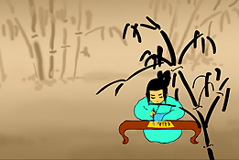 | 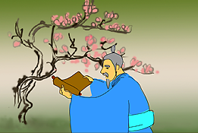
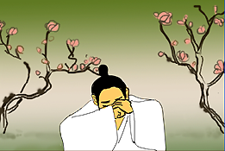 | 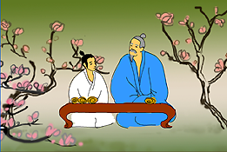
Story adapted from (Northern Dynasty) Biography of Yi Shi, Book of Wei (by Wei Shou)

- Let Us Discuss
- 假如孔璠不肯放下老師的尊嚴去向李謐學習，這對他在學術上的發展會有甚麼影響呢？
- 李謐的學識已超越孔璠，為甚麼仍然虛心向老師學習呢？
- 大家互相學習有甚麼好處呢？試分享你的經驗。
- 你同意「青出於藍，勝於藍」這句話嗎？試和同學分享一下你的看法。

- Quotations from the Classics
（戰國）呂不韋《呂氏春秋‧用眾》
(Warring States Period) Chapter "Yong Zhong",
Master Lu’s The Spring and Autumn Annals (by Lu Buwei)
善學者，假人之長以補其短。
(People who are good at learning will learn from other’s strong points so as to make up for their own weaknesses.)

（唐）魏徵《群書治要．體論》
(Tang Dynasty) Chapter "Ti Lun", Qun Shu Zhi Yao (by Wei Zheng)
君子下學而無常師，小人恥學而羞不能。
(Gentlemen have no single teacher and they learn from various people instead. They also do not mind learning from someone with a lower social status. However, people of low quality are reluctant to learn from other people as they regard this as a sign of incompetence.)

（戰國）荀子《荀子．儒效》
(Warring States Period) Chapter "Ru Xiao", Xunzi (by Xunzi)
知而好問，然後能才。
(Even though you are clever, you still have to work hard and always learn from others before you can make yourself a talented person.)

Information: The Biography of Yi Shi The Biography of Yi Shi, one of the "25 dynastic histories", was written by Wei Shou of the Northern Dynasty. It recorded the history from the early years of Xianbei Tuo Ba Bu to the years of Northern Qi, which replaced Eastern Wei. Contents of the book include important events of the emperors, social policies and natural phenomenon, descriptions of people with different social status and their family trees; and a lot of information about the ethnic minorities. The book is packed with valuable materials.

