Path to Moral Excellence
Personal Growth：Being Broad-Minded
Understand the objective constraints; learn to face failure and frustration

Story：The Frank and Broadminded Di Renjie

- Learn from a Story
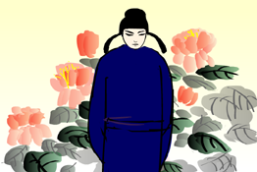 | 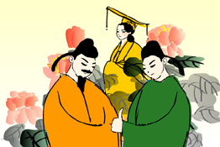
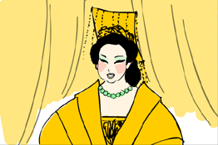 | 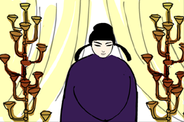
Story adapted from (The Five Dynasties) Biography 39: "Di Renjie", Old Book of Tang (by Liu Xu)

- Let Us Discuss
- 狄仁傑為甚麼沒有興趣知道誰在背後中傷他？你認為他的為人怎麼樣？
- 你曾經被別人中傷嗎？當時你有甚麼感受？試說一說。
- 如果你多次被人中傷，你會怎樣做呢？狄仁傑的做法值得我們借鑒嗎？
- 假如你的朋友因為被別人說壞話而生氣，不快樂，你會怎樣開解他，幫助他以曠達坦蕩的態度去面對問題呢？

- Quotations from the Classics
《論語‧述而第七》
Chapter 7 "Transmitting Insight, But", The Analects
君子坦蕩蕩，小人長戚戚。
(Gentlemen are so open and bighearted that they can lead a happy and carefree life. However, people of low quality are burdened by their own selfishness so they always lead an unhappy and uneasy life.)

Original Text:
子曰：「君子坦蕩蕩，小人長戚戚。」

（宋）朱熹《名臣言行錄》
(Song Dynasty) Ming Chen Yan Xing Lu (by Zhu Xi)
嘉賞未嘗喜，抑挫未嘗懼。
(Never become conceited when you are praised or awarded. Never get panicky and lose your confidence when there are setbacks.)

（宋）江致《乞復用李綱、种師道疏》
(Qing Dynasty) Chapter "Zhong Shidao Shu",
Qi Fu Yong Li Gang (by Jiang Zhi)
一勝一負兵家常事，小勝固未足為喜，小挫亦豈足為辱。
(Success and failure are common. Never be overjoyed for a trivial success, nor be ashamed for an insignificant failure.)

Information: Old Book of Tang Old Book of Tang, one of the "25 dynastic histories", composed by Liu Xu and others of the Five Dynasties. It is the earliest history book systematically recorded the history of the Tang Dynasty which still exists. The book primarily described some important events of the emperors, social policies and natural phenomenon. It also gave descriptions of people from all walks of life and the important writings about them. The book kept a lot of essential historical materials and is very informative.

