Path to Moral Excellence
Personal Growth：Beautifying One’s Soul
Admire the nature; be artistic; enjoy life leisurely;
enjoy moments of tranquility;
not to care too much about frame and wealth

Story：Wen Yuke Drew Bamboos

- Learn from a Story
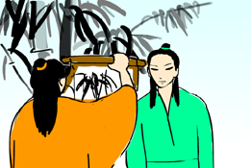 | 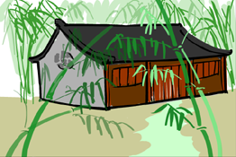
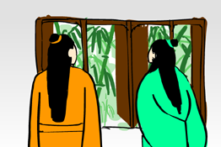 | 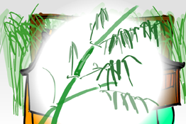
Story adapted from (Song Dynasty) "Wen Yuke Hua Yun Dang Gu Yan Zhu Ji" (by Su Shi)

- Let Us Discuss
- 為甚麼文與可能夠畫出精彩的竹畫呢？
- 文與可喜歡竹子，那你喜歡甚麼植物呢？你喜歡的植物有甚麼吸引人的地方呢？
- 當你置身於大自然青翠的環境中時，你會有甚麼感覺呢？試跟同學分享一下。
- 你喜歡栽種植物嗎？你認為這種嗜好能夠怡情養性嗎？試說說你的經驗和看法。

- Quotations from the Classics
(宋)蘇軾《書晁補之所藏與可畫竹三首》之一
(Song Dynasty) Inscription on the Collection of Chao Buzhi –
"The Drawing of Bamboo by Yuke" (One of Three) (by Su Shi)
與可畫竹時，見竹不見人。豈獨不見人，嗒然遺其身。其身與竹化，無窮出清新。
(When Wen Yuke drew bamboos, he just focused on the bamboos but not the people. Actually not only the people, he would even neglect his own body. In fact his body had combined with the bamboos, so that his paintings could always express freshness and briskness.)

(宋)歐陽修《學書為樂》
(Song Dynasty) Enjoy Learning (by Ouyang Xiu)
明窗淨几筆硯紙墨皆極精良，亦自是人生一樂。
(It is a great pleasure if I can possess a clean and tidy house with delicate stationery for Chinese calligraphy and painting.)

(晉)陶淵明《歸去來辭》
(Jin Dynasty) The Return (by Tao Yuanming)
悦親戚之情話，樂琴書以消憂。
(I love listening to the truth told by my family members and relatives, and love playing musical instruments and writing calligraphy to ease my worries.)

Information: Wen Yuke Hua Yun Dang Gu Yan Zhu Ji Wen Yuke Hua Yun Dang Gu Yan Zhu Ji, selected from Su Shi Wenji, was written by the famous scholar, Su Shi, of the Song Dynasty, in memory of his late friend Wen Yuke. The author described Wen’s theory of drawing bamboos, Wen’s behaviour, the poems and jokes between he and Wen; and their close friendship, in order to express his grieving feelings of missing everything about his friends. This book is touching and is filled with emotions.

