Path to Moral Excellence
Interpersonal Development: Respecting Others
Respect others’ rights and feelings
Story：The Feudal Princes Cheated by the Beacon

- Learn from a Story
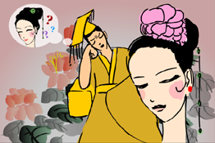

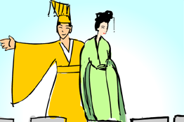 | 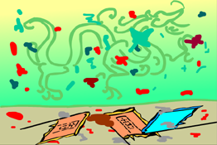
Story adapted from (Han Dynasty) Biographies of Zhou You and Bao Si, Biographies of Eminent Women (by Liu Xiang)

- Let Us Discuss
- 周幽王「烽火戲諸侯」，最後令到國家滅亡。你認為這是周幽王自作自受，還是諸侯沒有盡到勤王的本份呢？為甚麼？
- 你曾經被別人戲弄過嗎？你當時有甚麼感受？試說說你的經驗。
- 遇到那些經常愚弄別人的人，你會怎樣做？怎樣幫助他們改過呢？
- 假如班長、糾察經常無禮地呼喝同學，你還願意聽從他們的話嗎？為甚麼？
- 你希望別人(如：朋友、父母、老師等)怎樣尊重你？你又會怎樣尊重他們呢？

- Quotations from the Classics
《論語‧雍也第六》
Chapter 6 "Jan Yang is the One Who", The Analects
君子可逝也，不可陷也；可欺也，不可罔也。
(Gentlemen might be condemned but not trapped. They might be cheated but not fooled.)

Original Text:
宰我問曰：「仁者，雖告之曰，『井有仁焉。』其從之也？」子曰：「何為其然也？君子可逝也，不可陷也；可欺也，不可罔也。」

（明）高攀龍《高子遺書》
(Ming Dynasty) The Letter Left by Gao Zi (by Gao Panlong)
我惡人，人亦惡我；我慢人，人亦慢我。
(If I hate others, others will also hate me in return. If I belittle others, others will also belittle me in return.)

（漢）劉向《説苑．談叢》
(Han Dynasty) Chapter "A Corpus of Well-know Saying",
Garden of Anecdotes (by Liu Xiang)
好稱人惡，人亦道其惡；好憎人者，亦為人所憎。
(If you like to criticize others, others will also criticize you. If you hate others, others will also hate you.)

Information: Biographies of Eminent Women Biographies of Eminent Women, by Liu Xiang of the Han Dynasty, is the earliest Chinese history book about women. The author inherited the moral belief of Confucianism in the Pre-Qin Dynasty and the Three Cardinal Guides by Dong Zhongshu. He promoted the ethics and etiquettes of the feudal system in the book and supported the idea of being a virtuous wife. The book recorded the achievements of over one hundred women and described various types of women with different characters, including queens, concubines of kings, wives of feudal princes and common people. This literary work enriched the contents of ancient literature as well as the subject matters of literary writings. It was definitely a breakthrough in the history of literature.

