Path to Moral Excellence
Interpersonal Development: Being Generous and Understanding Others
Accept multilateral viewpoints; be tolerant to different opinions;
be generous and forgiving
Story：Lian Po’s Humble Apology

- Learn from a Story
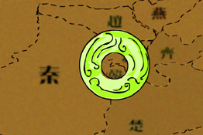 | 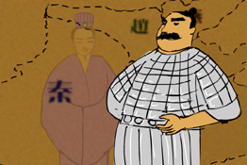
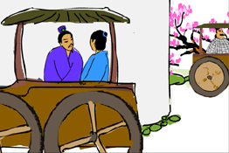 | 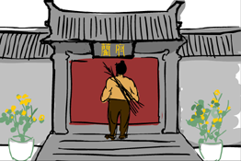
Story adapted from (Han Dynasty) Biographies of Lian Po and Lin Xiangru, Records of the Grand Historian (by Sima Qian)
- Let Us Discuss
- 廉頗為甚麼想羞辱藺相如？你對他這種作為有甚麼看法呢？
- 藺相如處處迴避廉頗，是軟弱的表現嗎？試說說你的想法。
- 如果開罪你的人向你道歉，你會原諒他嗎？試以一個生活故事進行角色扮演。
- 你明白「宰相肚裏好撐船」這句話的意思嗎？你認為作為一個領導人，有必要具備這種條件嗎？

- Quotations from the Classics
《論語‧子張第十九》
Chapter 19 "Zi Zhang", The Analects
君子尊賢而容眾，嘉善而矜不能。
(Gentlemen respect virtuous people, tolerate everyone, praise capable people and show sympathy to people who are less able.)

Original Text:
子夏之門人，問「交」於子張。子張曰：「子夏云何？」對曰：「子夏曰：『可者與之，其不可者拒之。』」子張曰：「異乎吾所聞：『君子尊賢而容眾，嘉善而矜不能。』我之大賢與，於人何所不容。我之不賢與，人將拒我，如之何其拒人也！」

（清）李寶嘉《官場現形記》
(Qing Dynasty) Revealing Original Shape in Officialdom (by Li Baojia)
宰相肚裏好撐船。
(A prime minister should have a mind so broad that even a boat could float inside it.)

《管子．形勢》
Chapter "The Situation", Guanzi
海不辭水，故能成其大。山不辭土，故能成其高。
(The ocean is so vast because it never rejects any water. The mountain is so tall because it never repels any rock and earth.)

Information: Records of the Grand Historian Records of the Grand Historian is one of the "25 dynastic histories" and is also the first book to present history in a series of biographies. The book, written by Sima Qian of the Western Han Dynasty, recorded history of more than two thousand years, from the years of Huangdi to the years of Emperor Wu of Han, and made a detailed record of the happenings during the Warring States Period, the Qing and the Han Dynasty. Contents of the book varied from political achievements of the emperors, track records of nobles and feudal princes, social policies and natural phenomenon and descriptions of people from all walks of life. The lists of big events of the year assisted readers to look up historic facts and the postscript section that commented on some historical figures and happenings served as a reference for the later generations. The whole book is covered with comprehensive information delivered in a refined style and outstanding evaluation.

