Path to Moral Excellence
Interpersonal Development: Being Generous and Understanding Others
Accept multilateral viewpoints; be tolerant to different opinions;
be generous and forgiving
Story：Zhu Chong Returned the Cow

- Learn from a Story
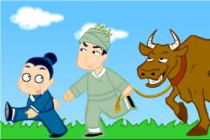 | 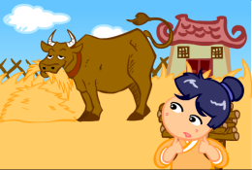
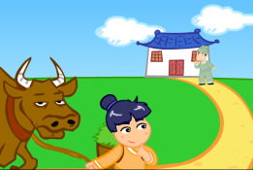 | 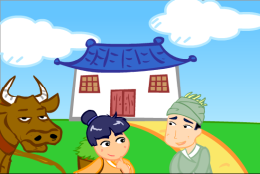
Story adapted from (Tang Dynasty) Biography No. 94 Zhu Chong, Book of Jin (by Fang Xuanling and others)

- Let Us Discuss
- 你覺得朱沖的為人怎麼樣？何以見得？
- 假如你是朱沖，看見別人的牛在吃自己的莊稼，你會怎麼做，為甚麼？
- 你認為寬大包容對你待人處事有甚麼幫助嗎？
- 如果你已經不斷忍讓包容，但別人依然毫無悔意，時常佔你的便宜，你會怎樣處理呢？試和同學討論一下。
- 試摘錄或創作一些有關寬大包容的句子，製成座右銘，提醒一下自己。

- Quotations from the Classics
《論語．衛靈公第十五》
Chapter 15 "Duke Ling of Wei", The Analects
躬自厚而薄責於人。
(Be strict to oneself, but not to others.)

Original Text:
子曰：「躬自厚而薄責於人，則遠怨矣。」

《尚書．周書．君陳》
Chapter "Jun Chen", Book Zhou, Book of Documents
有容乃大。
(A person who is tolerant is truly virtuous.)

Original Text:
爾無忿疾於頑，無求備於一夫。必有忍，其乃有濟；有容，德乃大。簡厥修，亦簡其或不修。進厥良，以率其或不良。惟民生厚，因物有遷。違上所命，從厥攸好。

《周易．坤》
Chapter "Kun", Book Zhou, Book of Documents
君子以厚德載物。
(Gentlemen can undertake important responsibility because they have great virtues.)

Original Text:
（坤卦）《象》曰︰地勢坤；君子以厚德載物。

Information: Book of Jin Book of Jin, one of the "25 dynastic histories", was a collaborative work from Fang Xuanling and Chu Suiling and others in the Zhenguan years in the reign of Emperor Taizong of Tang. The book recorded the history of the Western and Eastern Jin Dynasty and the Sixteen Kingdoms of the Northern Dynasty, including some important events of the emperors, history of the nobles and feudal princes, social policies and natural phenomenon, together with the descriptions of people from all walks of life. The postscripts also allowed emperors to summarise the governance experience of the former dynasty.

