Path to Moral Excellence
Interpersonal Development: Being Generous and Understanding Others
Accept multilateral viewpoints; be tolerant to different opinions;
be generous and forgiving
Story：Be Nice to the Neighbours

- Learn from a Story
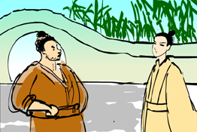 | 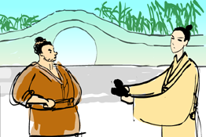
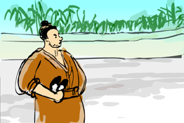 | 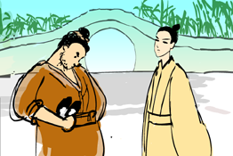
Story adapted from (Song Dynasty) Chapter 4, Dongpo Zhi Lin (by Su Shi)

- Let Us Discuss
- 沈驎士為甚麼把自己的鞋子給鄰居了呢？
- 故事中的鄰居，有哪些地方做得對？哪些地方做得不對？試加以說明。
- 如果你的同學誤以為你的物品是屬於他的，你會怎麼做？為甚麼？
- 沈驎士有甚麼地方值得我們學習？你認識有這種優點的人嗎？試和同學分享一下。

- Quotations from the Classics
《大戴禮記．子張問入官》
Chapter "Zi Zhang Asked about Being Charged with an Officer",
Elder Dai’s Record of Ritual
水至清則無魚，人至察則無徒。
(If the water is too clear, no fish can survive. If one is too stern, people would find one too difficult to get along and one will have no friends.)

注釋：1. 徒：同伴、朋友

《論語．堯曰第二十》
Chapter 20 "Emperor Yao Said", The Analects
寬則得眾。
(A person who is broadminded can win other people’s heart.)

Original Text:
謹權量，審法度，脩廢官，四方之政行焉。興滅國，繼絕世，舉逸民，天下之民歸心焉。
所重：民、食、喪、祭。
寬則得眾，信則民任焉，敏則有功，公則說。

（元）吳澄《元故都目龔國祥墓誌銘》
(Yuan Dynasty) The Epitaph of Official
Gong Guoxiang of Yuan Dynasty (by Wu Cheng)
寬於待人，恪於奉公。
(We should be generous to others and deal with public affairs cautiously and earnestly. Never be biased by personal sentiments.)

Information: Dongpo Zhi Lin Dongpo Zhi Lin, a work by Su Shi of the Song Dynasty, is about the various opinions and criticisms over history raised by Su Shi during the twenty years between Yuan Feng and Yuan Fu. Contents of the book covered a wide range of things and the length of the essays varied from a few to a thousand characters. Most of the writings are short, which were written freely. This showed the bold and humorous writing style of Su Shi.

