Path to Moral Excellence
Interpersonal Development: Being Grateful to Others’ Help
Help those who have helped you before
Story：Repaying a Meal

- Learn from a Story
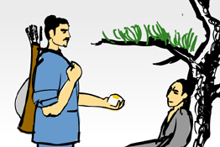 | 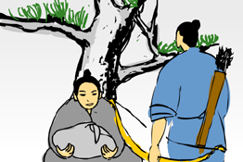
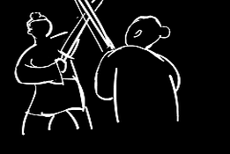 | 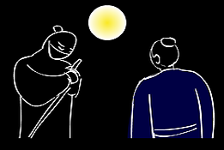
Story adapted from "The 2nd Year of Xuangong", Commentary of Zuo

- Let Us Discuss
- 你認為趙盾當初為甚麼會幫助靈輒？
- 假如你是靈輒，你會挺身而出保護趙盾嗎？為甚麼？
- 你曾經接受過別人的幫助嗎？試說出你的經歷和感受。
- 如果曾經幫過你的人需要你的幫忙，你會幫助他嗎？為甚麼？
- 試設計一張書籤或心意卡，答謝一位曾經幫助過你的人。

- Quotations from the Classics
（清）周希陶《增廣賢文》
(Qing Dynasty) Essays on Ancient Chinese Wisdom (by Zhou Xitao)
三生有幸，一飯不忘。
(Never forget anything which is kindly granted to you by someone, even if it is merely a meal.)

（晉）庾信《庾子山集‧徵調曲》
(Jin Dynasty) Chapter "The Tune of Zhi",
The Collection of Yu Zishan (by Yu Xin)
落其實者思其樹，飲其流者懷其源。
(One should thank the kindness of the tree after picking its fruit, and the kindness of the source after drinking its water.)

（明）呂坤《呻吟語．應務》
(Ming Dynasty) Chapter "Dealing with Affairs",
Words of Groan (by Lu Kun)
獲飽暖之休，思作者之勞；享尊榮之樂，思供者之苦。
(We should think of the hard work of the labourers who provide us with nice clothes and good food, and think of the difficulties of the people who contribute to our prosperity.)

Information: Commentary of Zuo Commentary of Zuo is a piece of literary work with history essays. The contents mainly stated the history of struggles between feudal princes of different states during the Spring and Autumn Period, which included descriptions of some important battles, ancients’ comments on some historic events, descriptions of social cultures and etiquettes at that time, as well as diplomatic documents, etc. So, this book is an important reference to study the history of the Pre-Qin period and the Spring and Autumn Period. It was written with simple but concise wordings in a lively manner and descriptions of suitable length. This book also concretely explained the happenings of the characters, described their images and briefly commented on the historic events and people. Original Text： 初，宣子田於首山，舍于翳桑，見靈輒餓，問其病。曰：「不食三日矣。」食之，舍其半。問之，曰：「宦三年矣，未知母之存否，今近焉，請以遺之。」使盡之，而為之簞食與肉，寘諸橐以與之。既而與為公介，倒戟以禦公徒，而免之。問何故。對曰：「翳桑之餓人也。」問其名居，不告而退，遂自亡也。

