Path to Moral Excellence
Interpersonal Development: Being Grateful to Others’ Help
Help those who have helped you before
Story：Unforgettable Gratitude

- Learn from a Story
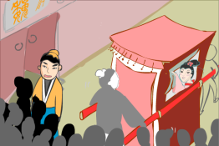 | 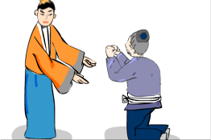
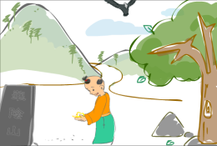 | 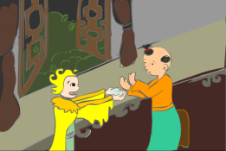
The "Jie Cao" story is adapted from "The 15th Year of Xuangong", Commentary of Zuo
The "Xian Huan" story is adapted from (Southern Dynasty) Biographies of Yang Zhen, Book of Later Han (by Fan Ye)
- Let Us Discuss
- 你認為魏顆和楊寶行善施恩時，有沒有想過將會得到回報呢？為甚麼？
- 誰對你的恩惠最大？你會怎樣回報呢？
- 想一想：我們可曾忽略一些關心我們照顧我們的人，忘了向他們表達感謝的心意呢？試與同學分享一下。
- 在社會上，有些人做了許多善事幫助別人，你覺得受恩惠的人應該知恩感戴嗎？為甚麼？
- 如果你的恩人要求你做一些你不想做或不應該做的事情（例如非法的勾當）來報答他，你會怎樣做呢？為甚麼？

- Quotations from the Classics
（漢）劉向《説苑．復恩》
(Han Dynasty) Chapter "To Pay a Debt of Gratitude",
Garden of Anecdotes (by Liu Xiang)
惟賢者能報恩，不肖者不能。植桃李者夏得休息，秋得其實；植疾藜者夏不得息，秋得刺也。
(Only virtuous people know to repay a favour, whereas the non-virtuous people do not. If you grow peaches and plums, you can take a rest in summer and then harvest in autumn. If you grow puncture vine, you still have to labour in summer, and all you harvest in autumn will be nothing but thorns.)

《戰國策‧趙策》
Chapter "The Strategy of Zhao", Strategies of the Warring States Period
用人之力而忘人之功不可。
(Never exploit others’ effort but forget their contribution afterwards.)

（漢）司馬遷《史記‧淮陰侯列傳》
(Han Dynasty) "Biography of the Marquis of Huaiyin",
Records of the Grand Historian (by Sima Qian)
乘人之車者載人之患;衣人之衣者懷人之憂。
(If someone gives me a ride, I should share his worries. If someone gives me clothes, I should care about his problems.)

Information: Commentary of Zuo Commentary of Zuo is a piece of literary work with history essays. The contents mainly stated the history of struggles between feudal princes of different states during the Spring and Autumn Period, which included descriptions of some important battles, ancients’ comments on some historic events, descriptions of social cultures and etiquettes at that time, as well as diplomatic documents, etc. So, this book is an important reference to study the history of the Pre-Qin period and the Spring and Autumn Period. It was written with simple but concise wordings in a lively manner and descriptions of suitable length. This book also concretely explained the happenings of the characters, described their images and briefly commented on the historic events and people. Original Text： 秋，七月，秦桓公伐晉，次於輔氏。壬午，晉侯治兵於稷，以略狄土，立黎侯而還。及雒，魏顆敗秦師於輔氏。獲杜回，秦之力人也。初，魏武子有嬖妾，無子。武子疾，命顆曰：「必嫁是。」疾病則曰：「必以為殉。」及卒，顆嫁之，曰：「疾病則亂，吾從其治也。」及輔氏之役，顆見老人，結草以亢杜回，杜回躓而顛，故獲之。夜夢之曰：「余，而所嫁婦人之父也。爾用先人之治命，余是以報。」
Information: Book of the Later Han Book of the Later Han, one of the "25 dynastic histories", was written by Fan Ye of the Southern Dynasty (excluding the parts on "social policies" and "natural phenomenon"). The book recorded the one hundred and ninety-five years of history of the Eastern Han Dynasty, including some important events of the emperors, history of the nobles and feudal princes, social policies and natural phenomenon, together with the descriptions of people from all walks of life and the important writings about them. This book was full of vivid standpoints and pinpoint criticism.

