Path to Moral Excellence
Interpersonal Development：Caring for Others
Respect the elderly; love the peers; care for the young

Story：Confucius was Concerned about People rather than His Belongings

- Learn from a Story
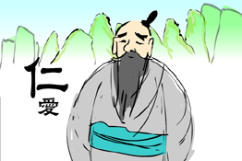 | 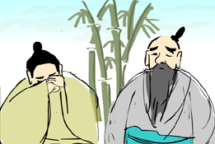
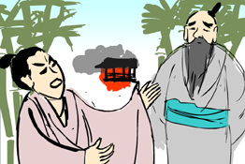 | 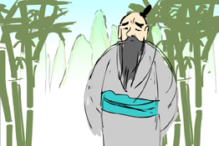
Story adapted from Chapter 10, "Xiang Dang", The Analects

- Let Us Discuss
- 孔子說人是善良的，每個人都有愛人的心，你同意嗎？請舉例說明。
- 怎樣才是有愛心的表現呢？試說說你的經驗。
- 假如你關心朋友，可是他卻不領情，你會怎樣做呢？
- 假如人人都自私自利，不懂得互愛，對世界有甚麼不良的影響嗎？有甚麼方法可改善呢？
- 試搜集一則關愛別人的新聞和同學分享。

- Quotations from the Classics
《孟子‧離婁下》
Chapter "Li Lou 2", Mencius
愛人者，人恆愛之；敬人者，人恆敬之。
(People love those who love them. People respect those who respect them.)

Original Text:
孟子曰：「君子所以異於人者，以其存心也。君子以仁存心，以禮存心。仁者愛人，有禮者敬人。愛人者，人恆愛之；敬人者，人恆敬之。有人於此，其待我以橫逆，則君子必自反也：我必不仁也，必無禮也，此物奚宜至哉？其自反而仁矣，自反而有禮矣，其橫逆由是也，君子必自反也；我必不忠。自反而忠矣，其橫逆由是也，君子曰：『此亦妄人也已矣。如此則與禽獸奚擇哉？於禽獸又何難焉？』是故君子有終身之憂，無一朝之患也。」

(宋)王應麟《三字經》
(Song Dynasty) Three Character Classic (by Wang Yinglin)
兄則友，弟則恭。長幼序，友與朋。
(Elder brothers and sisters should love their younger siblings, whereas the younger brothers and sisters should respect the elder siblings. People should observe the proper order between seniors and juniors, as should they bear a true and sincere heart when they deal with friends.)

(宋)王應麟《三字經》
(Song Dynasty) Three Character Classic (by Wang Yinglin)
親師友，習禮儀。
(We should be close to good teachers and nice friends and learn the appropriate etiquette from them.)

Information: The Analects The Analects has twenty chapters recording Confucius's words and deeds (including questions and answers between Confucius and his disciples, Confucius’s teachings, etc.) and his proposition. The information was presented in conversational form. The book was highly recommended as a classical work of Confucianism. Confucius raised the idea of humanity, defined the standard of moral ethics and promoted extensive teaching without class distinctions. The Analects conveyed impressive meanings with simple wordings in short paragraphs and many of the contents were later extracted and became mottos and idioms. Original Text： 廄焚，子退朝，曰：「傷人乎？」不問馬。

