Path to Moral Excellence
Interpersonal Development：Caring for Others
Respect the elderly; love the peers; care for the young
Story：Tiying Saved Her Father

- Learn from a Story
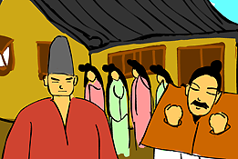 | 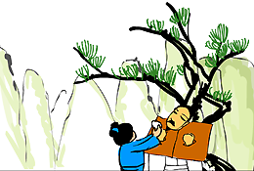
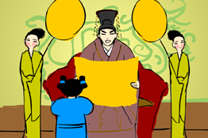 | 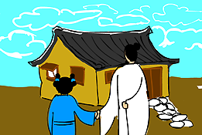
Story adapted from (Han Dynasty) Biographies of Bian Que and Cang Gong, Records of the Grand Historian (by Sima Qian)

- Let Us Discuss
- 漢文帝釋放緹縈的父親並廢除肉刑，這是關懷顧念的行為嗎？為甚麼？
- 是甚麼原因驅使緹縈上京救父的？你對緹縈的行為有甚麼看法呢？
- 你有沒有試過主動為父母做點事情，減輕他們的辛勞？試說說你的經驗。
- 你認為一個孝順的孩子最應該怎樣對待父母呢？為甚麼？
- 試查找一些有關孝順父母的格言，然後貼在壁報板上和他人分享。

- Quotations from the Classics
《孟子‧盡心下》
Chapter "To Fathom the Mind 2", Mencius
孩提之童，無不知愛其親者，及其長也，無不知敬其兄也。親親，仁也；敬長，義也。無他，達之天下也。
(Small children know they should love their parents. When they grow up, they know they should respect their elder brothers. Loving our parents is humaneness, and respecting our elder brothers is righteousness. It is not for any reason, but because humaneness and righteousness are human nature.)

Original Text:
孟子曰：「人之所不學而能者，其良能也。所不慮而知者，其良知也。孩提之童，無不知愛其親者，及其長也，無不知敬其兄也。親親，仁也。敬長，義也。無他，達之天下也。」

(唐)孟郊《遊子吟》
(Tong Dynasty) A Traveller’s Song (by Meng Jiao)
誰言村草心，報得三春暉。
(Who says our appreciation of our mother that is as tiny as a grass can repay their love that is as warm as the sunshine in spring?)

(宋)王應麟《三字經》
(Song Dynasty) Three Character Classic (by Wang Yinglin)
香友九齡，能温席。孝於親，所當執。
(In Eastern Han dynasty, there was a nine-year-old boy called Huang Xiang who would warm his parents’ bed during winter before they went to sleep. As sons and daughters, we should all take such a filial act as example.)

Information: Records of the Grand Historian Records of the Grand Historian is one of the "25 dynastic histories" and is also the first book to present history in a series of biographies. The book, written by Sima Qian of the Western Han Dynasty, recorded history of more than two thousand years, from the years of Huangdi to the years of Emperor Wu of Han, and made a detailed record of the happenings during the Warring States Period, the Qing and the Han Dynasty. Contents of the book varied from political achievements of the emperors, track records of nobles and feudal princes, social policies and natural phenomenon and descriptions of people from all walks of life. The lists of big events of the year assisted readers to look up historic facts and the postscript section that commented on some historical figures and happenings served as a reference for the later generations. The whole book is covered with comprehensive information delivered in a refined style and outstanding evaluation.

