Drama education for Primary Schools
Session 1
Understanding Bullying (1)

Objective: | To learn about bullying and the three major roles in a bullying incident (the  Bullies, the Victims, and the Bystanders).
Target: | Primary 4 to 6 students
Suggested  Duration: | 1 lesson (35minutes)
Teaching Aids: | Appendix 1a “Identifying Bullying Incidents”, Appendix 1b “Definition of Bullying”, Appendix 1c “Bullying Close-up”, Appendix 1d “Types of Bullying”, Appendix 1e “The Three Roles in a Bullying Incident”, video clips, paper, pens, VCD player/computer, and relevant news reports on school bullying.

Duration | Teaching steps | Remarks
10  minutes - Warm-up exercise | - Teacher tells the class about today’s focus on the bullying problem.  - Teacher asks, “Do you know what bullying is?”  - Identifying bullying incidents (group activity)  - Form groups of 4 to 6 students.  - Teacher narrates the story of video clips one by one or different school scenarios. After each video clip, students are required to judge whether it is a bullying incident by having a show of hands. “Hands up if you think it is a bullying incident, make a cross with hands if you think it is not.”  - Teacher asks, “Why do you think this is / is not bullying?”  - Invite students to share their comments / explanations.  - Teacher leads students to conclude the definition of bullying, and provide supplementary information.  Bullying refers to a person or a group of | See Appendix 1a “Identifying Bullying Incidents”  Teacher may choose the appropriate videos  /scenarios according to the time available and the major concern.  See Appendix 1b  “Definition of Bullying”, post it up in the classroom.

persons harming or intimidating others intentionally by suppressing the weak or the minority. Generally, there are three features:
- Repetition – Bullying behavior repeats over a period of time. It is not a single incident.
- Malicious intent – Bullies oppress and hurt others deliberately.
- Imbalance of power – Bullies are apparently more powerful, and bullying occurs when the victims are unable to protect themselves.
20  minutes - Activity | Bullying close-up (Group activity)  - Form groups of 4-6 students.  - Teacher teaches students how to perform the task with “Still Image” and “Thought Tracking”.  - Teacher first explains:  - When the teacher says ‘Freeze’, students should show a still posture, similar to the still image of the videotape when we press the “pause” button (Still Image).  - When the teacher puts his hands on a student’s shoulder, the student should speak his mind as if he / she were the character (Thought Tracking).  - Teacher chooses 3 scenarios from Appendix 1a for the groups to perform and discuss with students the different types of bullying in the scenarios and the different roles involved.  - Teacher’s conclusion:  The three types of bullying:  - Physical bullying: e.g. punching and kicking.  - Verbal bullying: e.g. humiliating in public, names-calling, mocking, verbal threatening, using abusive languages and taunting loudly.  - Indirect bullying: e.g. spreading rumours, being hostile deliberately and isolating someone.
 |  | Teacher invites students to demonstrate “Still Image” and “Thought Tracking”.
See Appendix 1c
“Bullying close-up”
 |  | See Appendix 1d “The Three Types of Bullying” and Appendix 1e “The Three Roles in a Bullying Incident”. Post them up in the classroom.

 | - The three roles in a bullying incident: Bullies, Victims and Bystanders
5 minutes - Reflection and conclusion | - Reflection  - Students spend one minute to reflect on what they have learnt about bullying in this session.  - Teacher invites students to share their views.  - Teacher’s conclusion  - Bullying is not for “fun”. It is building one’s happiness upon others’ pain and is definitely intolerable. Some bullying behaviours seem trivial, such as names-calling, teasing, etc., but in fact, cause big harm to the victims. If the persons involved do not take appropriate actions to put an end to such behaviours, they may further develop into more serious behavioural problems.  - There are three roles involved in a general bullying incident: “Bullies”, “Victims” and “Bystanders”. All of them can contribute to building a harmonious school and hence everyone has the responsibility to prevent bullying incidents from happening.  - In the next session, we will look at the feelings of the different roles in a bullying incident.
.
~~The end~~

Appendix 1a
Identifying Bullying Incidents

Teachers may select the following scenarios as appropriate according to the needs of students.

- Synopsis of video clips

- Synopsis of “Who is my companion?”
Ka-ki accidentally dropped her ball pen in between classes. Nin-kam picked it up for her out of kindness. However, Ka-ki did not show a bit of appreciation, and she even laughed at Nin-kam’s stinking smell. The other two students nearby joined in and mocked Nin-kam. Just then, the teacher entered the classroom and asked the students to divide into groups for discussion. Ka-ki threatened and lured her classmates to isolate Nin-kam. As a result, Nin-kam was left standing at the center of the classroom since nobody wanted her in their groups.

****This is a case of bullying.

- Synopsis of “This is not a game”
During recess, Wai-ho put his pencil case on his head out of boredom, pretending to be the beggar “Chi Kung”. Watching this, Chi-hei started to laugh at Wai-ho with his two friends. Other students also rallied and cheered for Chi-hei’s act. At lunch, Chi-hei and others were creating troubles in the classroom. Wai-ho was in the classroom too. Again, Chi-hei and his friends mocked at Wai-ho and dirtied his books and belongings.

****This is a case of bullying.
- School scenarios

Scenario (1)
Kin-long, who was short and fat, had articulation problems due to some defects with his tongue. As a result, he became a laughing stock of his classmates. At recess, two classmates surrounded Kin-long, teased about his build and imitated his pronunciation while calling him the name, “Mo Tai Long”. Kin-long wanted to leave the scene but they blocked his way.

****This is a case of bullying.

Scenario (2)
Siu-tung was excellent academically, but thin and weak. One morning, two classmates took Siu-tung’s mathematics workbook from his schoolbag without his permission and copied his answers. When Siu-tung tried to get his workbook back, they threw it around to make fun of him like ‘a monkey chasing the ball’. At last, Siu-tung’s face was hit by the workbook.

****This is a case of bullying.

Scenario (3)
One day, two students were punished by their teacher since they had brought their digital game devices to school. They suspected it was Ka-ho who reported the incident. During recess, they surrounded Ka-ho maliciously while pushing him and threatening him.

****This is not a case of bullying (occasional occurrence), but taking revenge is unacceptable itself.

Scenario (4)
Chi-fai missed a shot of penalty kick in the Inter-class Football Competition, and the team was knocked out. The next day the entire class boycotted Chi-fai. They did not talk to him and avoided him all day. After a few days, they became friends again, chatting and laughing together.

****This is not a case of bullying (an individual case), but boycotting is unacceptable itself.

Scenario (5)
After each music lesson, Siu-ming always liked to throw his music book at Kwong-yu and beat him, and then ordered him to bring the book back to the classroom.

****This is a case of bullying.

Scenario (6)
Students were queuing to play table tennis during recess. Chi-chung, his classmate, suspected that Sing-cheung was jumping the queue and argued with him. They started to quarrel and beat up with each other.

****This is not a case of bullying (a conflict), but it is inappropriate to solve problems with violence.

Scenario (7)
During recess, Ling-ling passed by Lik-wai. Not only did Lik-wai name Ling-ling the “Princess of Odour” and tell others not to play with her, but he also made fun of her personal hygiene issues and claimed that Ling-ling only washed her hair once a month.

****This is a case of bullying.

Scenario (8)
Chi-wai always forced Ming-fai to finish homework for him before lessons. If Ming-fai disobeyed, Chi-wai would throw Ming-fai’s stationery on the floor and shouted at him in public.

****This is a case of bullying.

Scenario (9)
At lunchtime, whenever Siu-yuet opened her lunchbox, her neighbouring classmate, Chi-wah would grab some of her food to eat immediately.

****Whether this is a case of bullying depends on how Siu-yuet feels. If she is happy to share food with Chi-wah, this is not a case of bullying. Otherwise this is a case of bullying.

Scenario (10)
Whenever exercise books were passed around, classmates in Mei-fan’s group often tried to avoid touching hers with every possible means. In case of touching her exercise books, they would immediately clamour to have their hands washed. This made Mei-fan very embarrassed.

****This is a case of bullying.

Scenario (11)
Being introverted and timid, Ching-ching was regarded as a softy and often teased by her classmates. One day, she wore a new pair of shoes to school. Two classmates stepped on her shoes intentionally, claiming that was an “opening ceremony”. Still, they were not satisfied and kept tugging Ching-ching’s uniform, leaving it full of creases.

****This is a case of bullying.

Scenario (12)
At recess, Kwok-chung came up to Wai-kit again and snatched his pocket money. He warned him not to tell the teacher or he would ask someone to beat him up after school.

****This is a case of bullying.

Appendix 1b

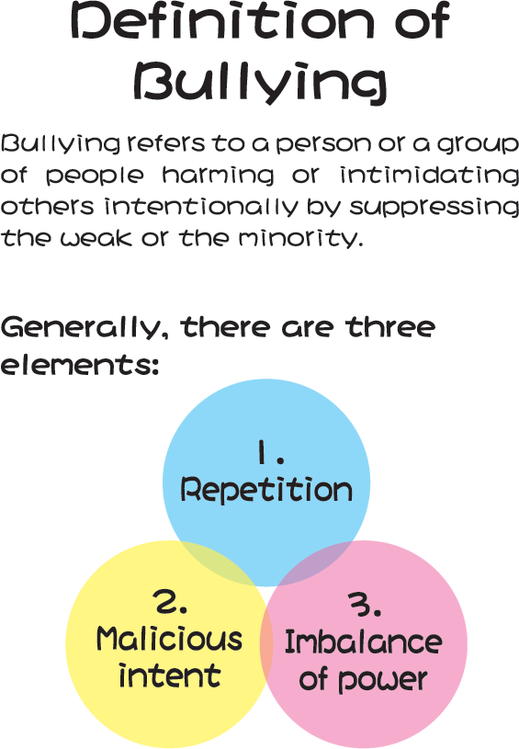

Appendix 1c
Bullying close-up
School scenarios

Scenario (1)
Kin-long, who was short and fat, had articulation problems due to some defects with his tongue. As a result, he became a laughing stock of his classmates. At recess, two classmates surrounded Kin-long, teased about his build and imitated his pronunciation while calling him the name, “Mo Tai Long”. Kin-long wanted to leave the scene but they blocked his way.

Scenario (2)
Whenever exercise books were passed around, classmates in Mei-fan’s group often tried to avoid touching hers with every possible means. In case of touching her exercise books, they would immediately clamour to have their hands washed. This made Mei-fan very embarrassed.

Scenario (3)
At recess, Kwok-chung came up to Wai-kit again and snatched his pocket money. He warned him not to tell the teacher or he would ask someone to beat him up after school.

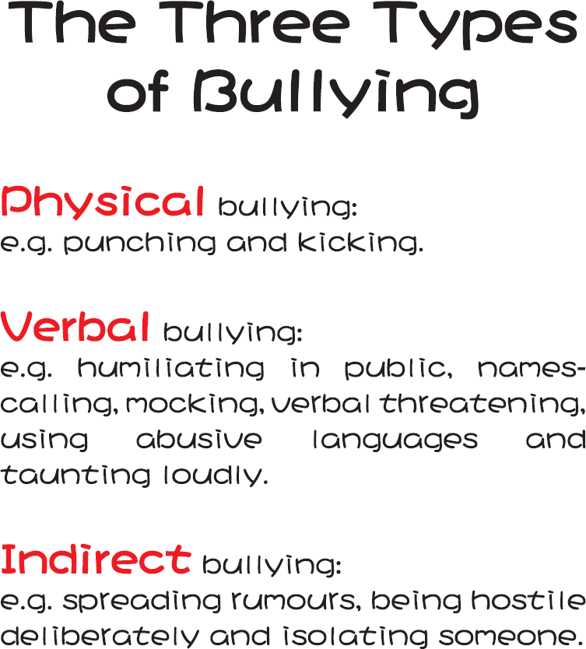
Appendix 1d

Appendix 1e

