Primary School Drama Education Session 2
Understanding Bullying (2)

Objectives: | - To help students understand and experience the feelings of the three roles in a bullying incident through acting out.  - To let students understand that “Stop bullying” is everyone’s responsibility.
Target: | Primary 4 to 6 students
Suggested  Duration: | 1 lesson (35 minutes)
Teaching Aids: | Appendix 1b “Definition of Bullying”, Appendix 1d “The Three Types of Bullying”, Appendix 1e “The Three Roles in a Bullying Incident” in session 1.

Duration | Teaching steps | Remarks
5 minutes - Warm-up exercise | - Revision: Teacher asks questions about the main points in Session 1  - What are the three features of bullying?  - What are the types of bullying?  - Which three roles are involved in a general bullying incident?  - Teacher states, “Today we will discuss about the feelings of these three roles in bullying”.  - Revision of the “Still Image” approach: Teacher sets a topic (e.g. a lion searching for food) and asks students to imagine and act freely. When Teacher says “Freeze”, students have to stop and project a still image of the moment. | Teacher may post up Appendix 1b “Definition of Bullying”, Appendix 1d “The Three Types of Bullying” and Appendix 1e “The Three Roles in a Bullying Incident” in Session 1.

20 minutes - Activity | - Re-enactment (Group Activity)  - Form groups of 4-6 students.  - Teacher revisits the video clip “Who is my Companion?” shown in Session 1 or asks students to act out their own version of a bullying incident.  - Each group first decides on the role of each student (the bullies, the victims and the bystanders).  - Each group is given two minutes to discuss how to act out the scene.  - Each group acts out their own version of the bullying incident. | The bullying incident to be selected should involve 3 different roles, i.e. the bullies, the victims and the bystanders. Teachers may make use of the bullying incident in Session 1 or ask students to act out their own version of a bullying incident.
 | - Understanding each character’s feelings  - Teacher invites students playing the role of the bullies in each group to put up a “still image” with their body and facial expressions to express the feelings of the bullies in the incident.  - Students are given 10 seconds to think of a sentence to best describe their feelings.  - Using the ‘Thought Tracking’ approach, when Teacher pats a student’s shoulder, that student immediately tells his / her thoughts / feelings.  - Teacher invites other students to share their feelings / opinions.  - Teacher explores the feelings of the victims and the bystanders with the same approach.  - Teacher may encourage students to tell a bullying incident that happened to them or discuss newspaper cuttings about bullying incidents and invite other students to share their feelings / opinions. | Teacher may take photos of each still image for future discussion/ posting.  If a real student case is chosen, subjective feelings and the school’s disciplinary mechanism will be involved. Teacher has to handle with care to avoid provoking students’ emotions and losing control of the situation.

10 minutes - Reflection and conclusion | - Reflection:  - Students are given one minute to reflect on what they have learnt about bullying in this lesson.  - What will be the consequences if nobody intervenes in the above situation?  - Teacher invites students to share their views.  - Teacher’s conclusion:  - Normally, if nobody intervenes, bullying incidents will continue to occur repeatedly. The suffering of the victims is long-term and difficult to recover. Some students quit school because of bullying, while others are depressed, dejected, frightened, in despair and some might even commit suicide.  - No one wants to be bullied, nor should anyone be bullied. Therefore, “Stop bullying” is everyone’s responsibility.  - In the next session we will look at the behaviour of the bullies.

~~The end~~

Appendix 1b

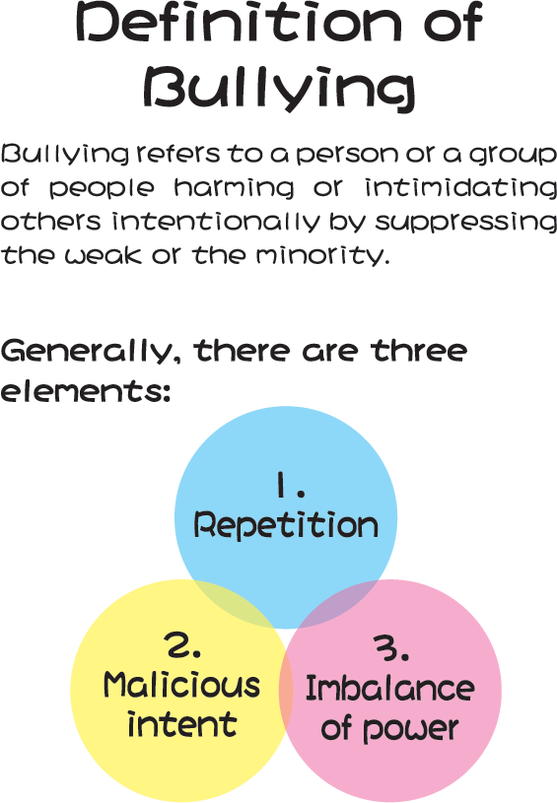

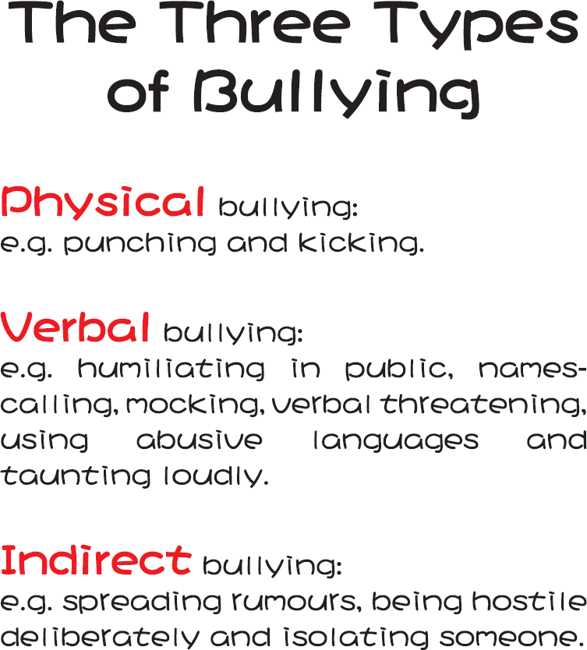
Appendix 1d

Appendix 1e

